[Greetings! Here is the Word version for ease of use. To imagine how this might look in a simple layout, please click here.]

Prioritizing You: May Health Observances
The greatest wealth is health! Following are ideas for participating in two of May’s main health observances, but there are hundreds throughout the year. Here is where you can view them all.

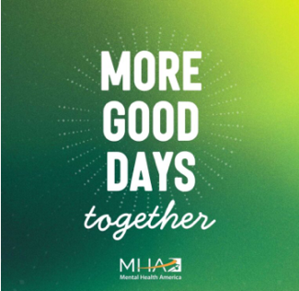
1. Mental Health Awareness: More Good Days, Together
The 2026 theme for Mental Health Month reminds us of the importance of reducing stigma and promoting mental wellness.
- Action: Explore the Action Guide for online activities, articles, printable tools, and practical resources.
- Action: Reflect on what a good day looks like for you, whether it’s reading a book, taking a walk, or a win at work.
- [ED. NOTE: Customize with EAP and other mental health resources at your organization.]

2. National Women’s Health Month: Health at Every Age

This year’s Women’s Health Month celebrates the achievements and validates the experiences women, non-binary, and transgender people face every day. Explore the resources.
- Action: Visit the onsite health station or your local pharmacy for a quick blood pressure screening. Aiming for a reading near 120/80 mmHg is a great goal for long-term vitality.
- Action: Check with your doctor, clinic, or electronic health record to ensure preventive care is up to date. If not, schedule needed appointments right away.
- [ED. NOTE: Customize with women’s health initiatives at your organization.]

###

