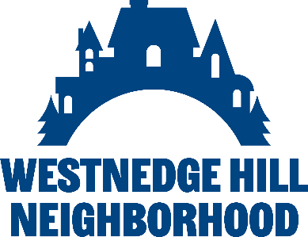 **Neighborhood Event & Idea Application**

Welcome to our Neighborhood Event/Idea Application process. We are excited to hear your ideas and collaborate on initiatives that will enhance the well-being, safety, and inclusivity of our community. This process is designed to ensure that everyone’s voice is heard, and that all activities and events reflect our shared values of equity, inclusion, and mutual respect.

At the heart of this community, we prioritize creating spaces where all neighbors feel safe, welcome, and supported. Your proposal should embody these values, promoting a sense of belonging and fostering connections that strengthen the bonds between us.

**Application Process:**

*Submit Your Idea*: Begin by filling out the application form with a detailed description of your proposed event or idea. This will allow us to understand the purpose, potential impact, and how it aligns with our community’s values.

*Review and Presentation*: After submission, your application will be reviewed by the board. If needed, we may invite you to attend a board meeting to present your idea and answer any questions from members. This ensures transparency and gives you the chance to clarify any details.

*Decision-Making*: The board will deliberate on the proposal, considering its potential to enhance the safety, inclusivity, and well-being of our neighborhood. Following the discussion, the members will vote on whether to approve the idea.

We are eager to collaborate with you in making our neighborhood a better place for all. Thank you for your commitment to our shared vision of community and connection!

Name:

Contact information:

Event Idea or Proposal:

Goal/Purpose of Event:

Date, time, duration, and location of event: (include if a space needs to be designated)

Estimated attendance:

Estimated cost of event:

Are you willing to attend a board meeting to preset proposed idea:

Any additional information: