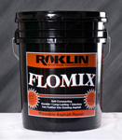
FloMix Asphalt
Rapid Repair
FloMix rupture strength is up to three times that of concrete, providing skin patches over damaged base pavement that survive heavy traffic. FloMix repairs asphalt with minimal delay with repairs that are strong and flexible with tenacious adhesion. Even in thin lifts, FloMix repairs survive long term under severe traffic loads. FloMix repairs are waterproof and fuel resistant.
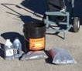
- Easy to apply, long-lasting and durable with pre-measured kits, no measuring, weighing, heating and no math! Add the pre-measured ingredients, mix and pour!
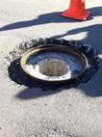
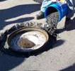
No pavement removal or demolition is needed. Repairs are completed quickly and there is minimal surface preparation.

- It is never too hot nor too cold to repair asphalt with FloMix.

- Repairs can be done in minutes using only 3 simple steps.

