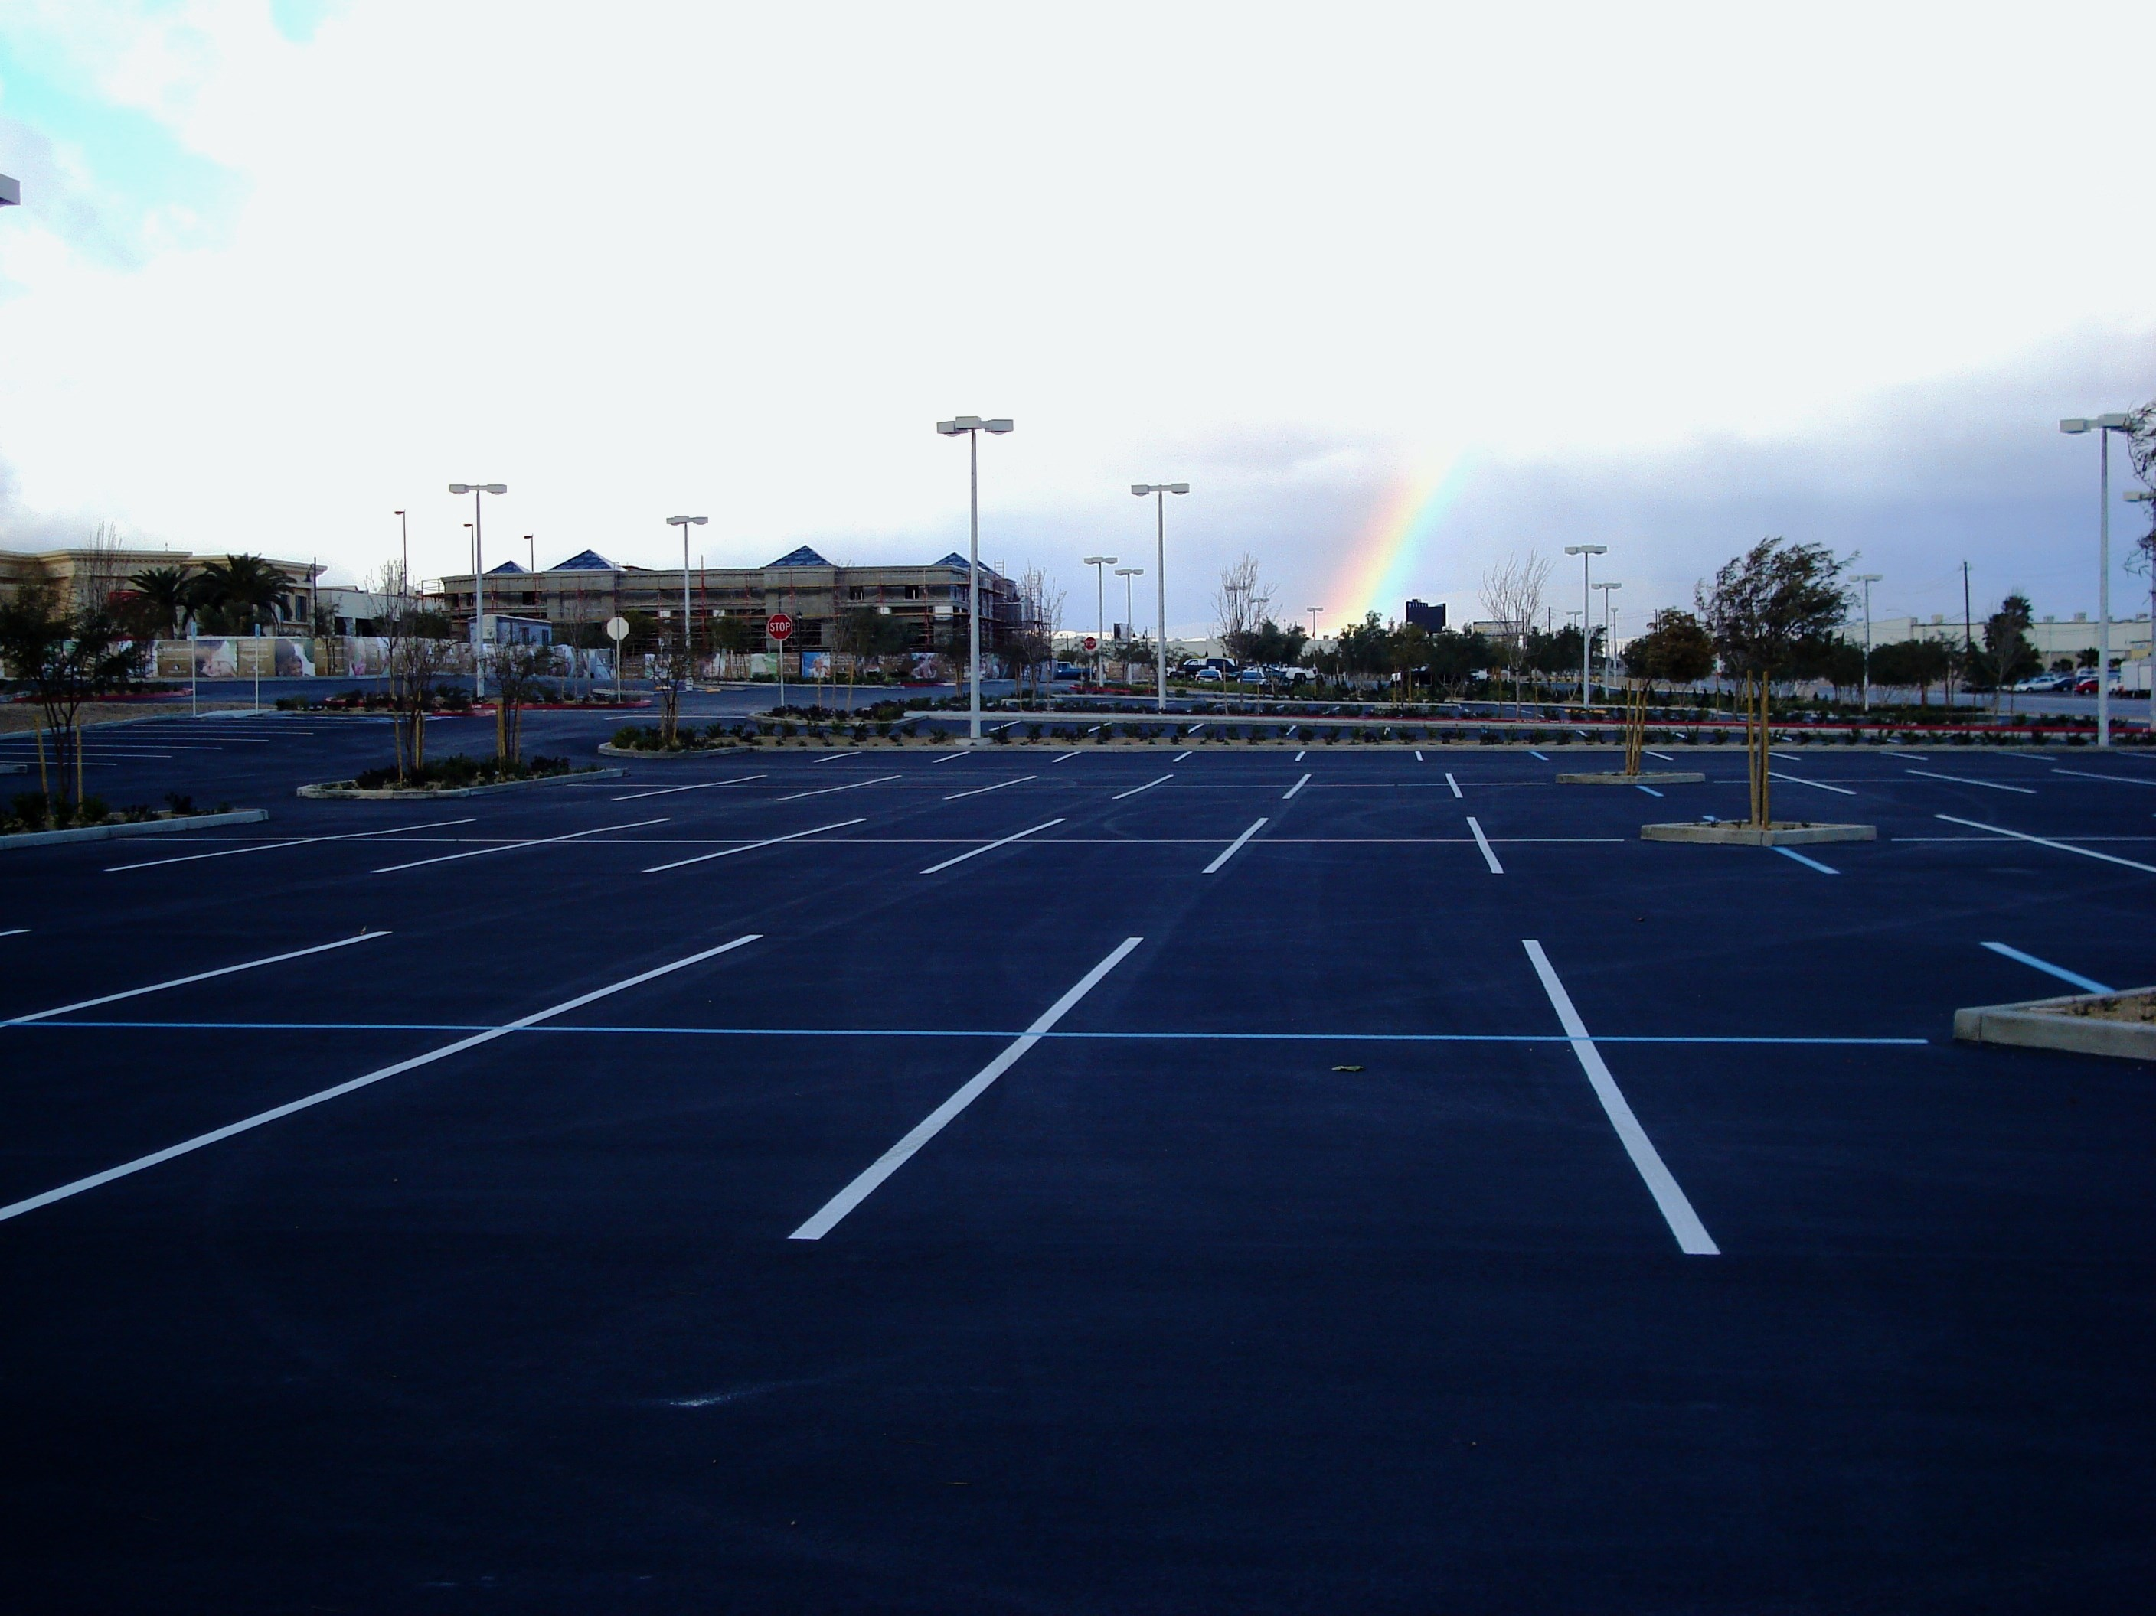

BREWER COTE® ACRYLIC COAT
BREWER COTE OF ARIZONA
5226 W. MISSOURI AVE
GLENDALE, AZ 85301
(623)931-3728 (888)931-3728
sales@brewercoteaz.com
www.brewercoteaz.com

DESCRIPTION
This highly milled emulsion uses the benefits of cationic binders and polymers, produces a superior sealer.
Acrylic Coat attaches and seals the asphalt sub-strait and is highly resistant to UV, water and fuel
Acrylic Coat is a blend of select mineral fillers, plasterers and asphaltenes in a stable P.G. Grade asphalt

ADVANTAGES

  - Protects surface from Ultra violet rays
  - Binds aggregate into surface, reduces raveling
  - Easy to apply
  - Fast Drying
  - Prevents water damage

  - Resists cracking and chipping better than other sealers
  - Environmentally safe
  - Oil and fuel resistant
  - Can be customized with aggregate Loading
  - Flexible coating

Characteristics
Method of Application: Brush, Squeegee or Conventional Oil spreading equipment
Color: Satin Black
Weather Limitations: For best results, do not apply on rainy, Foggy or extremely Humid days
or when temperature is expected to drop below 50° F during the next 6 hrs
Drying Time: 2 Hour Maximum
Clean Up: Water Soluble tar and asphalt remover
Packaged: 5 Gallon Pail (49Ibs), 55 Gallon Drum (520Ibs), Bulk 7.

 |  |  | Application Rate
Dilution Rate |  |  | Quantity of Emulsions |  |  |  | Quantity of Aggregate
 |  |  |  | gal/vd" (I/m2) |  |  | lb/vd" (kg/rn"
1:1 |  |  |  | 0.10 - 0.15 |  |  |  | 0.20 - 0.50
 |  |  |  | (0.45 - 0.68) |  |  | (0.11 - 0.27)
2:1 |  |  |  | 0.08 - 0.15 |  |  |  | 0.20 - 0.50
 |  |  |  | (0.36 - 0.54) |  |  | (0.11 - 0.27)
 |  | One to One Dilution Emulsion Properties
Properties |  |  |  | Specifications |  |  |  | Limits
In Ready to Apply form, one part concentrate to one part Water By Volume
Saybolt Furol Viscosity at |  |  |  | ASTM D244 |  |  | 10 - 50 Seconds
77"F (25°C)
Residue by Distillation or |  |  |  | ASTM D244 |  |  | 28.5 Minimum
Evaporation
Pump Stability' |  |  |  |  |  |  |  | Pass
 | Emulsion Residue by Distillation or Evaporation Tests
Properties |  |  |  | Specifications |  |  |  | Limits
Viscosity at 275°F (135°C) |  |  |  | ASTM D4402 |  |  | 1750 cts Maximum
Solubility in 1,1,1 |  |  |  | ASTM D2042 |  |  | 97.5 Minimum
Trichloroethlene
Penetration |  |  |  | ASTM D5 |  |  | 50 dmm Minimum
Asphaltenes |  |  |  | ASTM D2007 |  |  | 15 Minimum
Saturates |  |  |  | ASTM D2007 |  |  | 15 Minimum
Polar Compounds |  |  |  | ASTM D2007 |  |  | 25 Minimum
Aromatics |  |  |  | ASTM D2007 |  |  | 15 Minimum
 |  | Aggregate Material Gradation Requirements
 | Sieve Designation |  |  |  | Percentages of Weight
 | Square Openings |  |  |  | Retained Sieves
 |  | NO.8 (2.38mm) |  |  | 0
 | No. 16 (1.19mm) |  |  |  | 0-8
 | No. 20 (0.84mm) |  |  |  | 0-28
 | No. 30 (0.60mm) |  |  |  | 20-50
 | No. 40 (0.42mm) |  |  |  | 10-55
 | No. 50 (0.30mm) |  |  |  | 0-30
 | No. 70 (0.21mm) |  |  |  | 0-5
 | No. 100 (0.15mm) |  |  |  | 0-2
 | No. 200 (0.07mm) |  |  |  | 0-2

