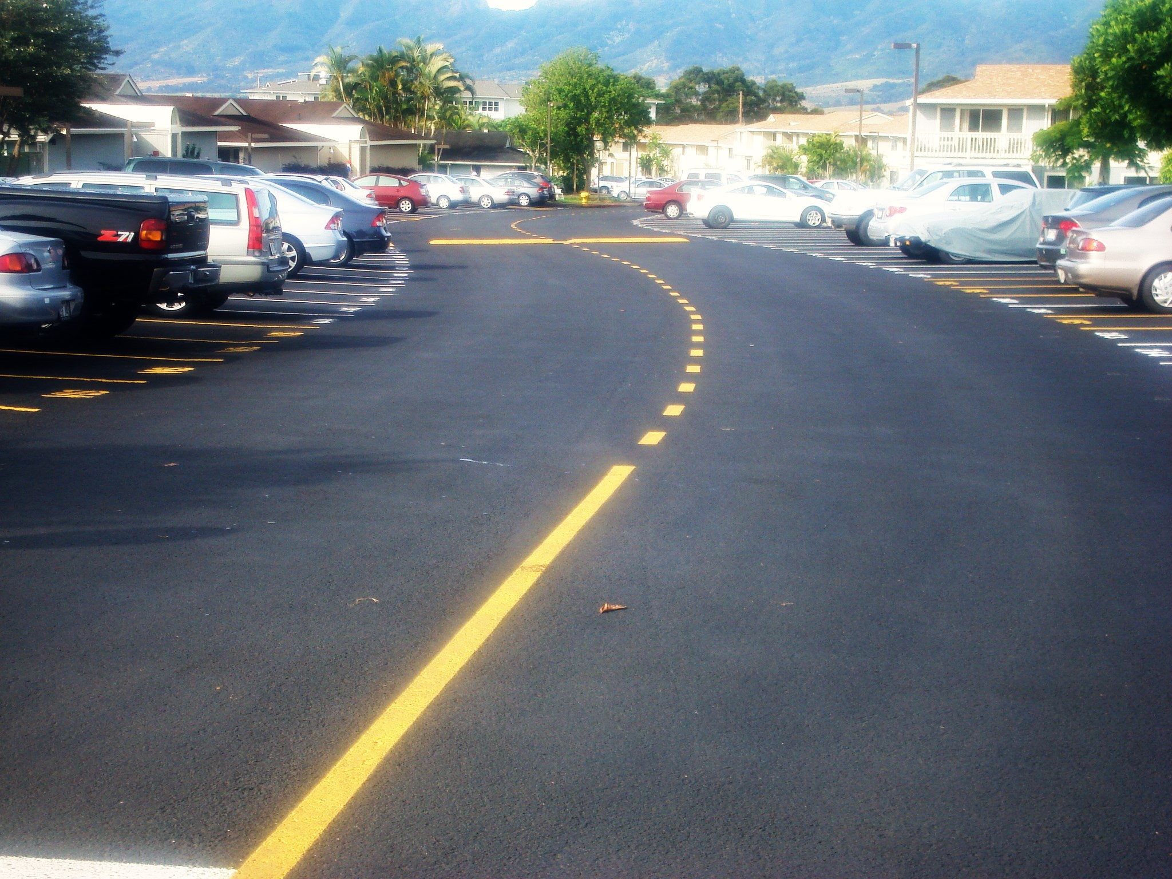
BREWER COTE® of Arizona
COAL TAR EMULSION
Brewer Cote of Arizona
5226 W Missouri Ave
Glendale AZ 85301
Phone: 888-931-3728
Fax: 623-842-0714
www.brewercoteaz.com

DESCRIPTION:
A heavy coal tar pitch emulsion containing rubber additives for greater adhesion and longer life, along with reinforcement geotextile fibers. Resists cracking caused by oxidation from sunlight and eliminates soft spots which form when gasoline, motor oil or jet fuel is spilled on asphalt. This proven professional coating may be used with complete confidence on any asphalt pavement. It is a continuing maintenance requirement for parking lots, driveways, gasoline stations, school yards, airport runways, or anywhere that the asphalt surface is exposed to gas and oil spillage, extensive abrasion, or weathering extremes.

Advantages:
- Meets all Federal, State FAA, and Military specifications.
- Resists hydrocarbons, gas, oil, and chemicals.
- Spray or squeegee application for customized results.
- Highly resistant to Ultra Violet light and water degradation.
- Tough durable finish that is skid resistant and reduces cleaning costs.
- Beautifies your pavement investment.
- Eliminates raveling and is non-scuffing.

COAL TAR EMULSION

Coverage:
50 to 100 square feet per gallon.
**Two coats are recommended on unsealed pavements, consult project manager.

Method of Application:
Make sure area is clean and free from all loose material and dirt. Squeegee or mechanical equipment product onto surface. Sand can be added at the rate of 1 to 6 pounds per gallon to provide greater traction and longer life. Two coats are recommended on unsealed pavements. Consult your project manager if needed.

Color: Charcoal black

Weather Limitations:
For best results, do not apply on rainy days or when the temperature is expected to drop below 50 degrees F during the next 24 hours. On hot days, the pavement shall be pre-dampened with fog system. New asphalt should not be sealed until after exposed to a full summer heat cycle. Ambient and surface temperature must be at least 55 F and rising during application. Do not apply if rain is in the forecast for the next 24 hours.

Drying time: 8 hours maximum at 70 degree's F, 50% relative humidity.

Clean up: When wet use water, dry use an asphalt/tar remover.

Packaging: bulk transport.

Specifications:
ITEM | FED. SPEC. R-P-355e | RESULTS
Specific gravity, 25' C  Non-volatile material | 1.20 Min. | 1.23
Percent Solids | 47% Min | 49.4
Ash Content % | 30-40% Min. | 34.6
Solubility in CS % | 20.0 Min. | 46.0
Water Content % | 53% Max. | 49.6
Drying Time- Hours | 8.0 Max. | 5.5

*Meets the following Requirements: ASTM D 5727, RP 355e, and ASTM D 3320-74T, FAA P627, P628, Brief 46a, ASTM D 140, ASTM D 466, ASTM B 117, ASTM D 529, ASTM D 2939, ASTM D 244

REV. 2/16

