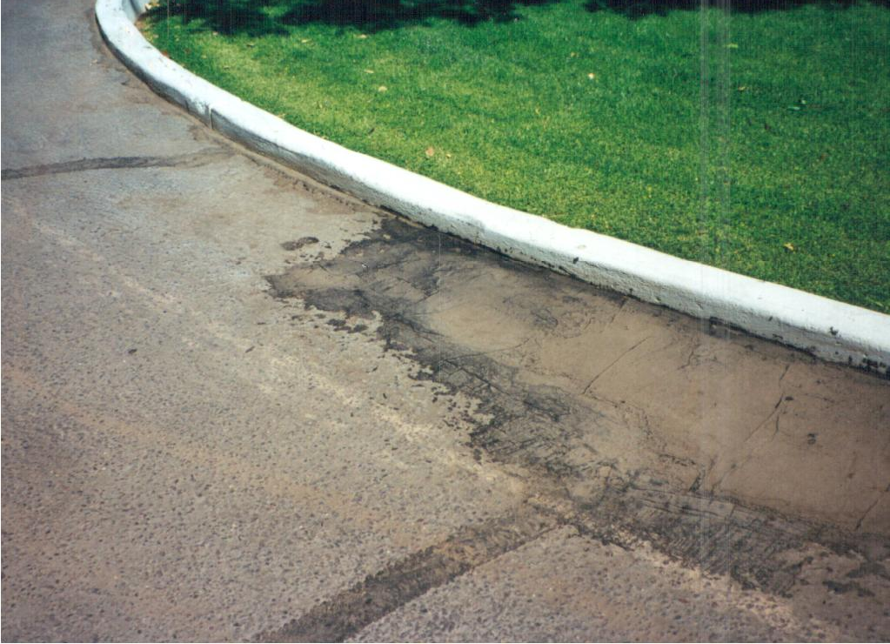

***BREWER COTE®***

**GATOR PATCH**

**(Trowel Grade Crackfiller)**

**DESCRIPTION**

Gator Patch is a blend of asphalt emulsion, mineral fillers, acrylic modifiers, and fibers designed especially for alligatoring and skin patch areas and other heavy duty repairs. This product should be used to build up depressions, fill expansion joints and wide cracks or any job requiring a trowel grade crackfiller. Gator Patch dries to a hard yet flexible surface that can be sealed over immediately.

***BREWER COTE®***

**CHARACTERISTICS:**

SURFACE PREPERATION: Surface must be dry, clean, and free from all loose material, dirt, and dust.

APPLICATION: Mix thoroughly for all applications. If product has been stored, turn pail

upside down for a few hours to aide in mixing before opening.

FILLING ALLIGATORED AREAS: Pour in alligatored areas and work with squeegee.

FILLING CRACKS: Fill cracks, scrape excess from surface before setting.

(Use V-shape squeegee).

FILLING BIRD BATHS: Fill with lifts of ¼” depth maximum; allow to harden before applying seal

coating.

WEATHER & LIMITATIONS: For best results, do not use when rain is in the forecast and temperature is not expected to drop below 55 degrees F. Gator patch is not a substitute for replacing asphalt, Gator Patch will prolong the life of the deteriorated asphalt.

COLOR: Black when dry

CLEAN UP: Paint Thinner or Biodegradable solvents.

NON-VOLATILES, %: 74% min.

ASTM D- 2939

ASH CONTENT %: 55% min.

ASTM D- 2939

SPECIFIC GRAVITY: 1.42 min.

ASTM D- 244

WET TRACK ABRASION: No Loss

ASTM D- 391 5lbs/5min

COVERAGE: 6 sq. ft gallon @ .25” thick 35 Linear Feet @ ½” wide x 1” deep

DRYING TIME: 4 Hours, based on 77º, 50% Hum. If traffic must be opened in one hour,

broadcast with sand.

PACKING: Five and Fifty-five gallon drums.

NOTE: Keep from freezing. Do not store in direct sunlight or where temperatures

exceed 100 F.