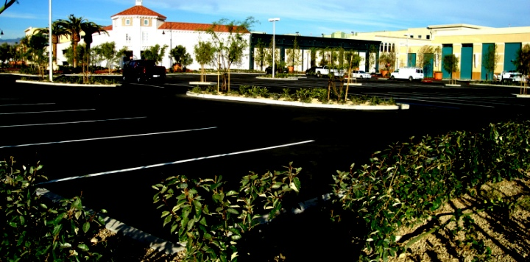

BREWER COTE® of Arizona
RESURFACER II

Brewer Cote of Arizona
5226 W Missouri Ave
Glendale AZ 85301
Phone: 888-931-3728
Fax: 623-842-0714
www.brewercoteaz.com

DESCRIPTION:
Resurfacer II is a milled blend of fiber reinforced asphalt, selected mineral fillers and acrylic and is polymer-modified. It is designed specially to increase the life expectancy of your asphalt. Resurfacer II beautifies and protects both old and new parking lots, recreational areas, and driveways against moisture and water penetration, ultraviolet rays from the sun, and oxidation. The tough, durable formula fills pavement voids and low spots by replacing fines that are lost during the aging process.

Advantages:
● Saves your pavement ● Better resistance to fuel & chemicals than competitive products
● Increase life expectancy ● Meets all state & public works Specifications
● Long lasting ● Can be squeegee applied to fill minor cracks & depressions
● Stops raveling ● Smooth flexible surface that is easy to clean

RESURFACER II

Coverage:
Smooth, dense pavements 2.0 gallons per 100 square feet
Medium Surfaces 3.0 gallons per 100 square feet
Rough, aged surfaces 4.5 gallons per 100 square feet
Excessively rough surfaces 5.0 gallons per 100 square feet
**Two coats are recommended on unsealed pavements, consult project manager.

Method of Application:
Make sure area is clean and free from all loose material and dirt. Squeegee or mechanical equipment product onto surface. Product may be diluted with a maximum of 20% water. Priming may be necessary on aged surfaces using one part SS-1H and four parts water and applied at 1 gallon per 100 square feet. Do not over dilute Resurfacer II. Two coats are recommended on unsealed pavements. Consult your project manager if needed.

Color: Jet black finish

Weather Limitations:
For best results, do not apply on rainy days or when the temperature is expected to drop below 50 degrees F during the next 24 hours. On hot days, the pavement shall be pre-dampened with fog system. New asphalt should not be sealed until after exposed to a full summer heat cycle. Ambient and surface temperature must be at least 55 F and rising during application. Do not apply if rain is in the forecast for the next 24 hours.

Drying time: 8 hours maximum at 70 degree's F, 50% relative humidity.

Clean up: Water before dry, use fuel oil when dry.

Packaging: 5 gallon pail (ship weight 54 lbs), 55 gallon drums (ship weight 610 lbs), or bulk transport.

Specifications:
METHOD MIN MAX RESULTS
Weight per gallon ASTM D244 10.0 lbs 10.1 lbs
Cone Penetration ASTM D217 340 mm 700 mm 370 mm
% Non-Volatile ASMA A-1 50 60 57
% Non-Volatile ASTM D2042 20 35 30
(Soluble in Trichloroethylene by wt)

*Wet track abrasion, ASTM D3910 15.3 4.6
(Grams per sq/ft)
Percentage Loss 5% 1.5%
*Modified for Sand Seal, 8 pounds + 10 minutes

REV. 2/16

