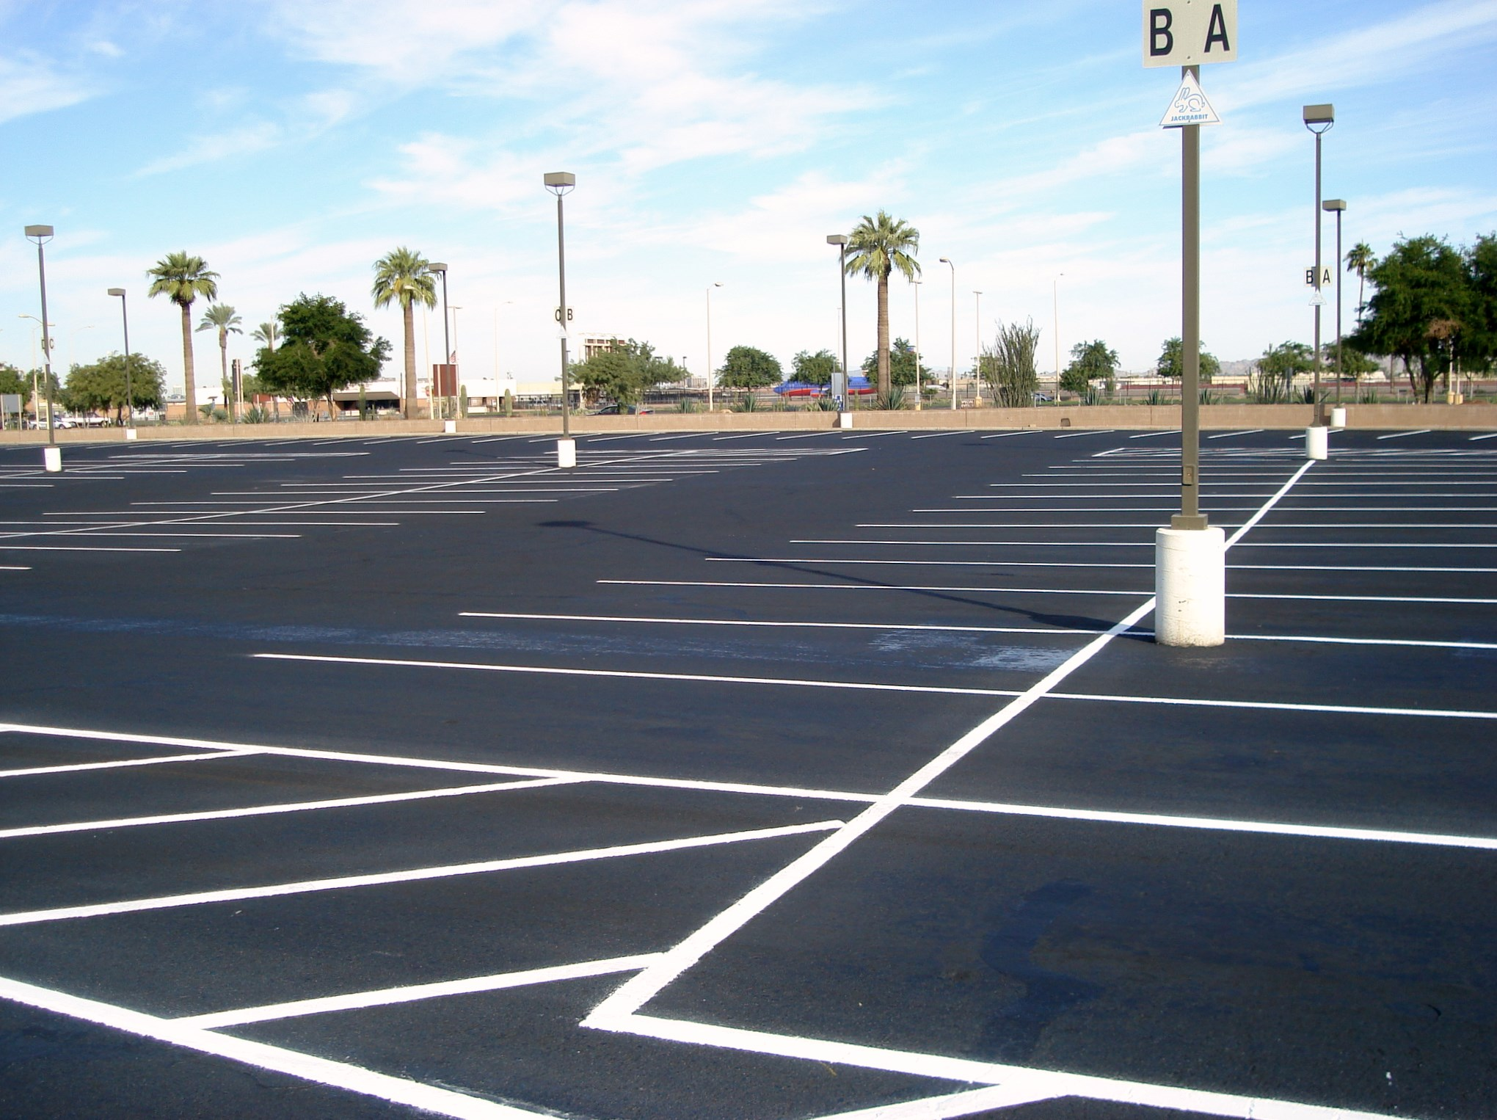
BREWER COTE® of Arizona
RESURFACER II +

Brewer Cote of Arizona
5226 W Missouri Ave
Glendale AZ 85301
Phone: 888-931-3728
Fax: 623-842-0714
www.brewercoteaz.com

DESCRIPTION:
Resurfacer II + is a milled blend of asphalt, selected mineral fillers and polymers. It is designed specially to increase the life expectancy of your asphalt. Resurfacer II + beautifies and protects both old and new parking lots, recreational areas, and roadways against moisture and water penetration, ultraviolet rays from the sun, and oxidation. The tough, durable formula fills pavement voids and low spots by replacing fines that are lost during the aging process.

Advantages:
● Saves your pavement ● Better resistance to fuel & chemicals than competitive products
● Increase life expectancy ● Meets all state & public works Specifications
● Long lasting ● Can be squeegee applied to fill minor cracks & depressions
● Stops raveling ● Smooth flexible surface that is easy to clean
RESURFACER II +

Coverage:
Resurfacer II + should be applies mixed (Resurfacer II, water, sand, and additives) at a rate of 50 - 70 square feet per gallon, per coat. If necessary an additional 10% water may be added for smooth
Application.

**Two coats are recommended on unsealed pavements, consult project manager.

Method of Application:
Make sure area is clean and free from all loose material and dirt. Squeegee or mechanical spray equipment product onto surface. Product may be diluted with a maximum of 20% water. An additional two pounds (50 – 70 mesh) maybe added for added filling properties along with additives for increased durability. Do not over dilute Resurfacer II +. Two coats are recommended. Consult your project manager if needed.

Color: Jet black finish

Weather Limitations:
For best results, do not apply on rainy days or when the temperature is expected to drop below 50 degrees F during the next 24 hours. On hot days, the pavement shall be pre-dampened with fog system. Ambient and surface temperature must be at least 55 F and rising during application. Do not apply if rain is in the forecast for the next 24 hours. Always allow new asphalt to cure through a summer season before sealing.

Drying time: 5 hours maximum at 70 degree's F, 50% relative humidity. Allow sealer to dry thoroughly between coats. Finial coat should cure for 24 hours.

Clean up: Water before dry, use biodegradable solvent when dry..

Packaging: 5 gallon pail (ship weight 54 lbs), 55 gallon drums (ship weight 610 lbs), or bulk transport (10 lbs per gallon).

Specifications:
METHOD MIN MAX RESULTS
Weight per gallon ASTM D244 10.5 lbs 10.8lbs 10.5 lbs
Polymer Modified% (Based on Asphalt Content) 3% Pass
% Non-Volatile ASMA A-1 50 60 55
% Non-Volatile ASTM D2042 20 35 30
(Soluble in Trichloroethylene by wt)
Penetration-Base Asphalt D5 10 45 35
Softening Point (Ring + Ball) D36 195 deg 210 deg
Asphalt Content, Weight % D2172 15 25 20%
Aggregate Content By Weight 33% 40% 35%
*Wet track abrasion, ASTM D3910 15.3 4.6
(Grams per sq/ft)
Percentage Loss 5% 1.5%
Water Resistance D4585 No Loss
Resistance to Impact D2939 Pass
Resistance to Heat D2939 Pass
QUV UV Aging, 1000 HAS. D4799 Pass
PAH % < .10%
Volatile Organic Compound (VOC) < 8 G/L

*Modified for Sand Seal, 8 pounds + 10 minutes
REV. 8/2019

