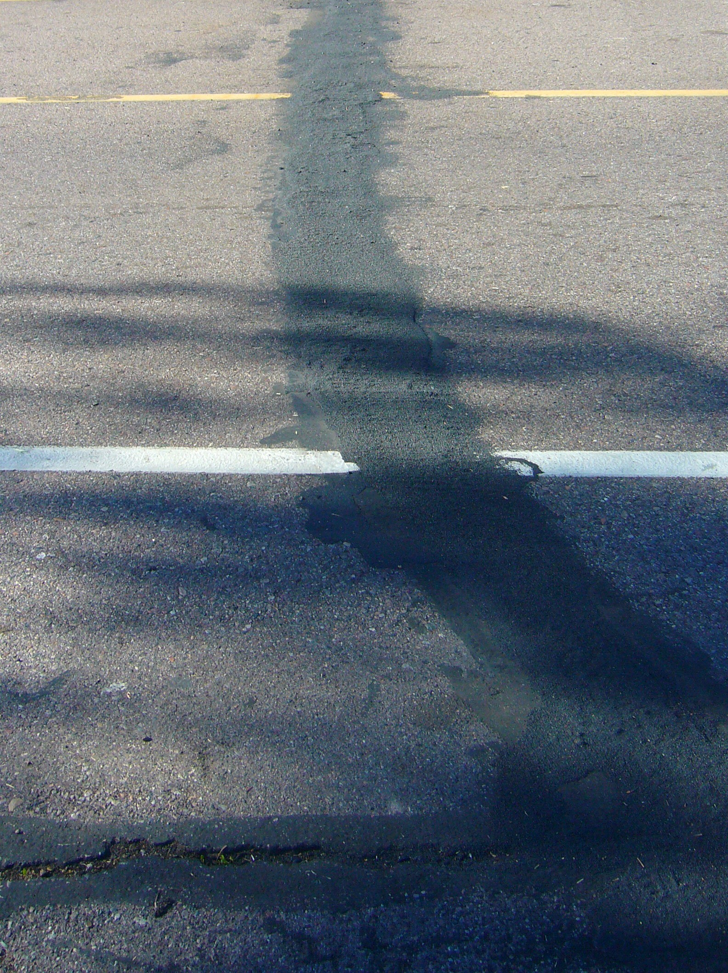
BREWER COTE® of Arizona
Brewer Cold Pour CrackFiller

Brewer Cote of Arizona
5226 W Missouri Ave
Glendale AZ 85301
Phone: 888-931-3728
Fax: 623-842-0714
www.brewercoteaz.com

DESCRIPTION:
Brewer Flex Cold Pour has been designed with additional acrylic and plasticizers to give you maximum elongation and resiliency in a ready to use product. Like our "Brewer Flex Hot Pour", no other product performs as well in both concrete and asphalt cracks and joints. Use Brewer Flex products when you want superior long lasting results.

Advantages:
- Ready to use
- Cost effective
- No Heating Necessary
- Flex at low temperature
- Great for hot climates
- Beautifies your pavement investment.
- Extends life of pavement

Brewer Cold Pour Crackfiller

Coverage:
Approximately 30 liner feet per gallon based on 1/2" wide by 1/2" deep cracks. Coverage will vary depending on width/depth of slot & type of application method.

Method of Application:
Stir before using, pour along crack out of the bottle or applicator. A second application may be necessary in deep cracks or joints.

Color: Black

Weather Limitations:
Do not apply if below 45 degrees F, or if rain is imminent, and is not going to fall below 45º for the next 24 hrs Pavement slots must be free of dust, dirt, and water prior to application. Use compressed air before applying sealant. Slot may be slightly damp to help penetration of sealant.

Drying time:
For best results, apply in clean dry cracks when temperature is not expected to drop below 50 deg F for the next 24 hours.

Clean up: Water prior to drying. Use Biodegradable PRISM (#465309 - #465310) solvent or a suitable solvent.

Packaging: 5 gallon pail (47lbs)

REV. 7/16

