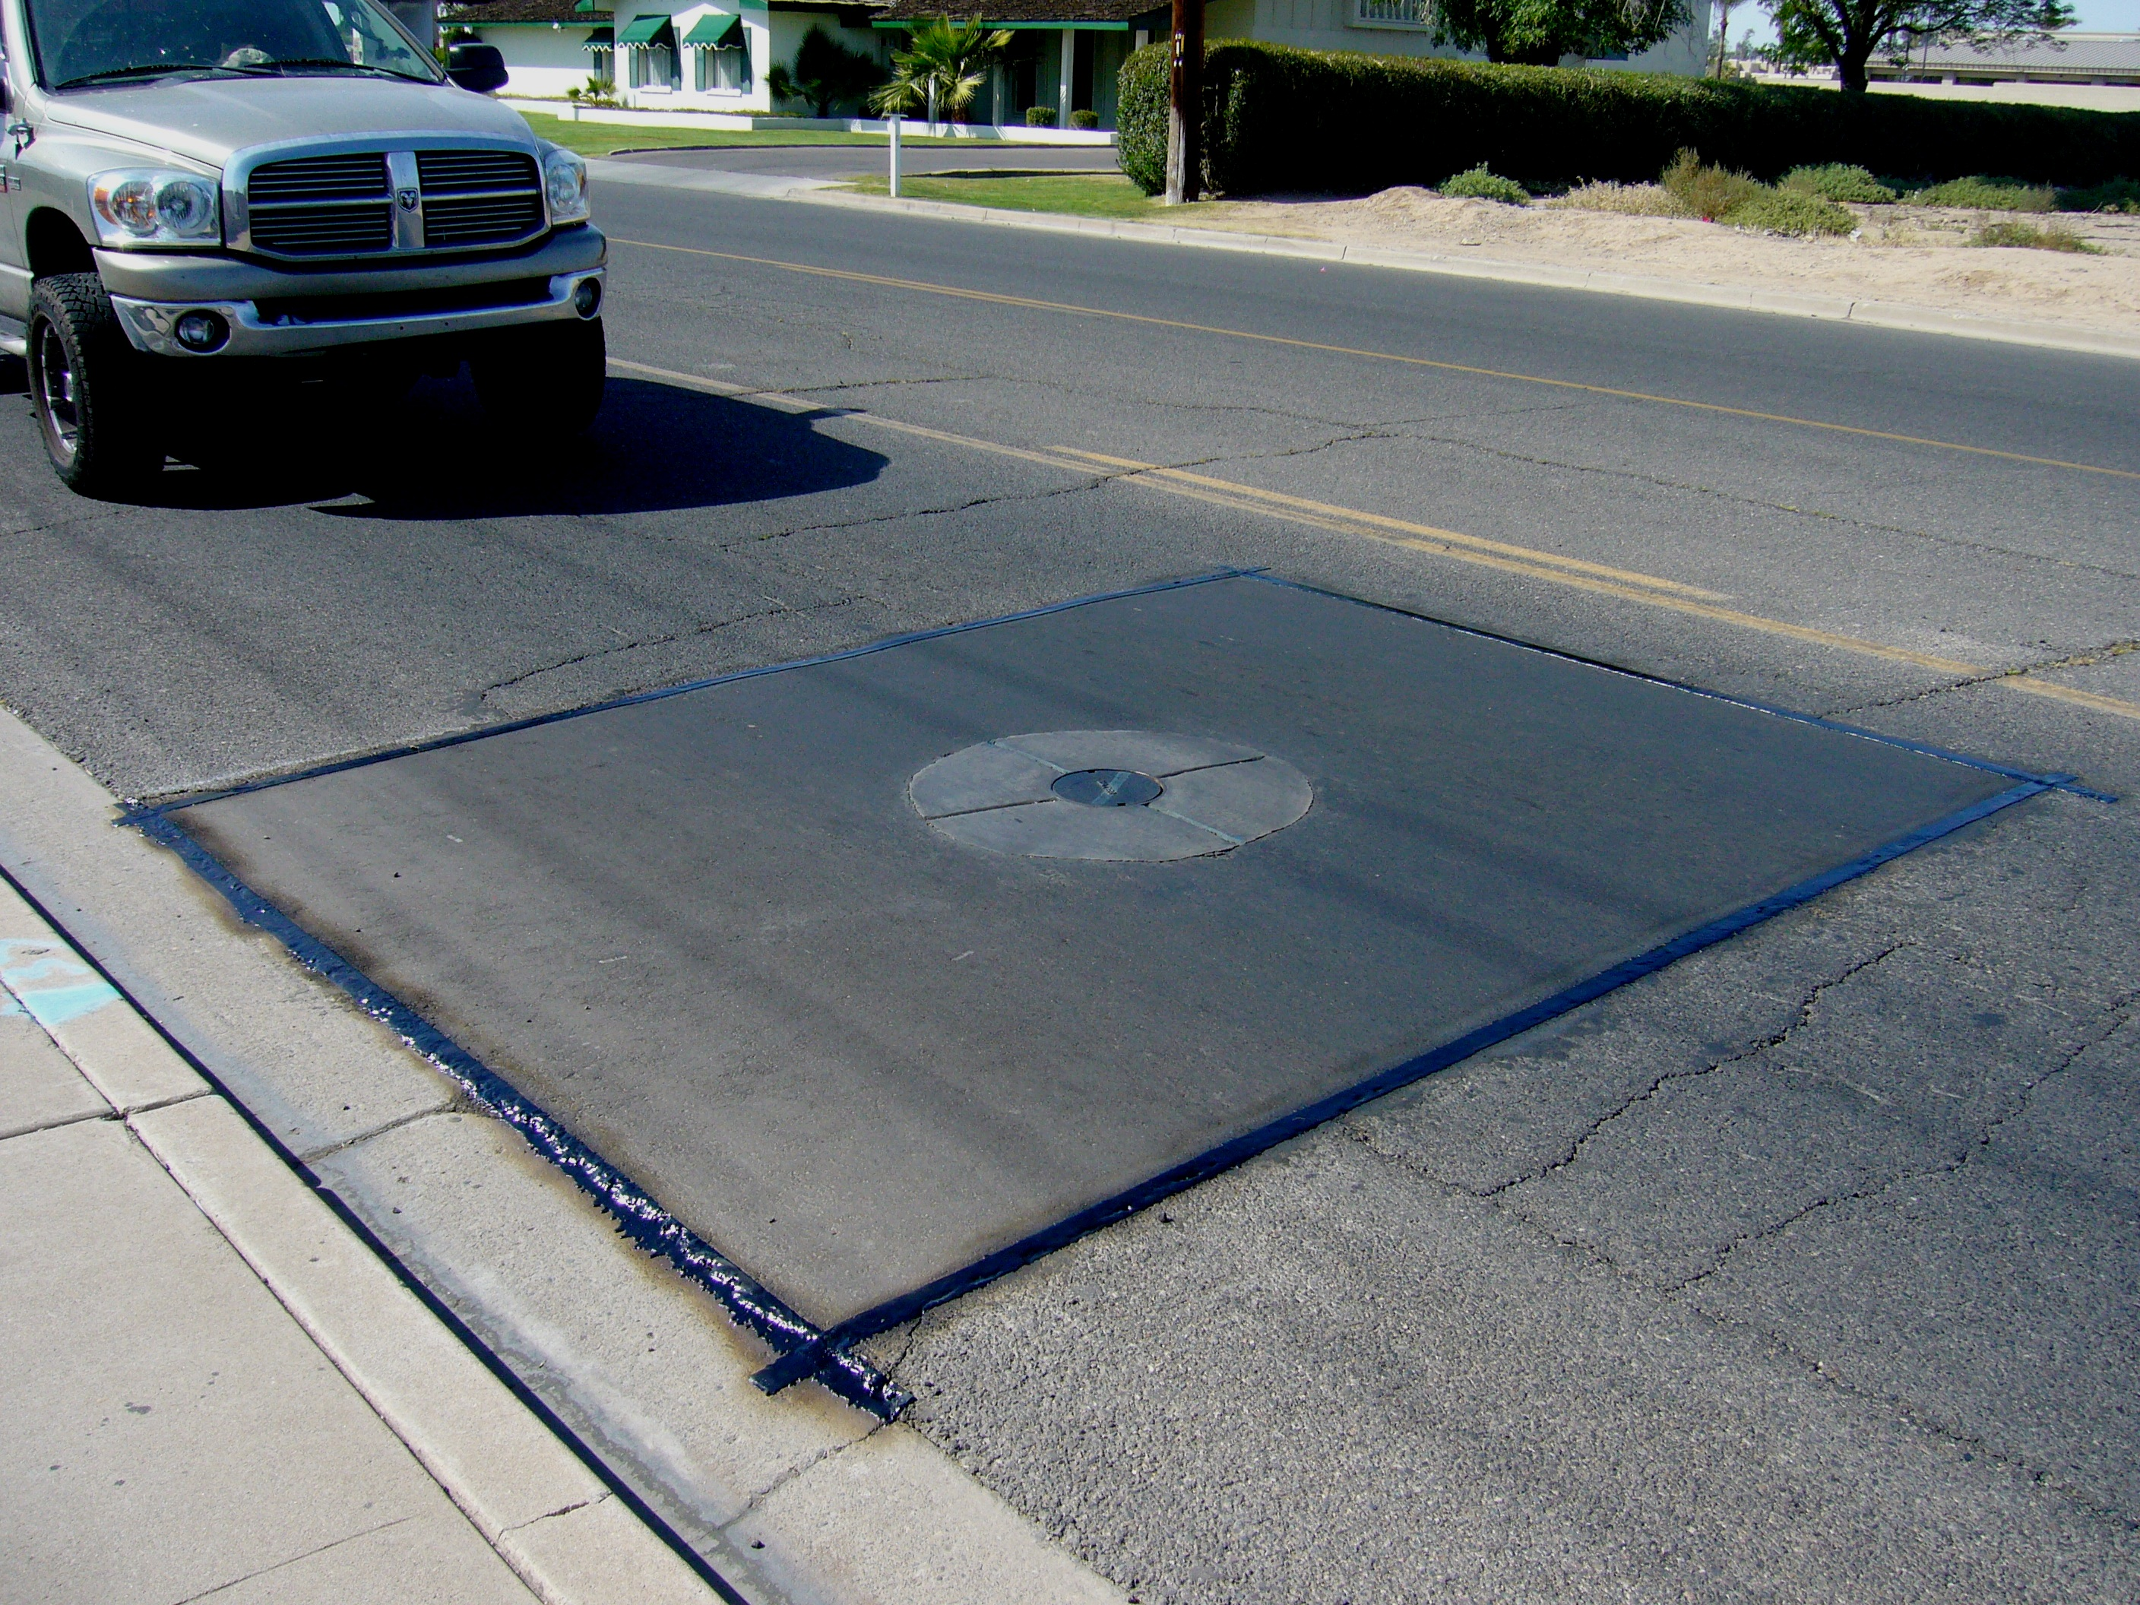
BREWER COTE® of Arizona
Brewer Cold Pour Loop Sealant

Brewer Cote of Arizona
5226 W Missouri Ave
Glendale AZ 85301
Phone: 888-931-3728
Fax: 623-842-0714
www.brewercoteaz.com

DESCRIPTION:
Brewer Cote Inductive cold pour, single component loop sealant is a one component pourable, sand, and acrylic modified asphalt emulsion for the use in sealing inductive wire loops and slots in asphalt and Portland cement concrete. This specially formulated sealant is acrylic modified to give greater flexibility in both hot and cold climates. It also skins over quickly to form a waterproof barrier. Brewer Cote's Inductive Cold Pour, Single Component Loop Sealant meets and exceeds Federal and State specification in Arizona, and other states. This product is made in America at Brewer Cote of Arizona Glendale AZ.

Advantages:
- Meets all Federal, State FAA, and Military specifications.
- Resists hydrocarbons, gas, oil, and chemicals.
- Spray or squeegee application for customized results.
- Highly resistant to Ultra Violet light and water degradation.
- Tough durable finish that is skid resistant and reduces cleaning costs.
- Beautifies your pavement investment.
- Eliminates raveling and is non-scuffing.

Brewer Cold Pour Loop Sealant

Coverage:
Approximately 15 liner feet per gallon based on 1/4" wide by 2" deep slots. Coverage will vary depending on width/depth of slot & type of application method. It is not recommended for slots bigger than 5/8". **Two coats are recommended on unsealed pavements, consult project manager.

Method of Application:
Loop Sealant can be applied by pressure feed, pump, directly from container, or by pour pot. B. C. Loop Seal is supplied ready to use, Leave pail upside down prior to use. Mix well with mechanical mixer to make all product uniform and the sand is disposed. Excess should be removed immediately by a V-Squeegee to force material into loop and to avoid excess waste.

Color: Black

Weather Limitations:
Do not apply if below 45 degrees F, or if rain is imminent, and is not going to fall below 45º for the next 24 hrs Pavement slots must be free of dust, dirt, and water prior to application. Use compressed air before applying sealant. Slot may be slightly damp to help penetration of sealant.

Drying time:
Tack free in one hour under normal conditions, (77 degree's F, 50% humidity). If traffic is unavoidable, broadcast fine dry sand over surface. Drying time will vary depending on surface temperatures. Test for traffic ability before opening.

Clean up: Water prior to drying. Use Biodegradable PRISM (#465309 - #465310) solvent or a suitable solvent.

Packaging: 5 gallon pail (53lbs) This product is made in America at Brewer Cote of Arizona Glendale AZ.

Specifications:
Item Test Procedures SpecificationsTypical Results
Viscosity, Saybolt Furol, D 244 25-150 125.0 Seconds, Range
Retained on No.20 Sieve, D 244(1) .10 .02
Percent, Maximum
Particle Charge D 244 Positive Positive

EMULSION (FOR CRACK FILLING

Pumping Stability (2) Pass Pass
Settlement, 5 Days Percent, Maximum D 244 5.0 Pass
Residue, percent Maximum D 244 (3) 60.0 68.0
TEST ON RESIDUE

Viscosity, 60 degrees F. D 2170 100-9,500 7,800
Centistokes, range

Molten Distribution, Ratio, Range D 2006-70 (4) 0.7-1.4 1.1
PC/S, Ratio, Minimum D 2006-70 (4) 0.50 0.80
Asphaltness, Percent Maximum D 2006-70 11.0 9.50
REV. 7/16

