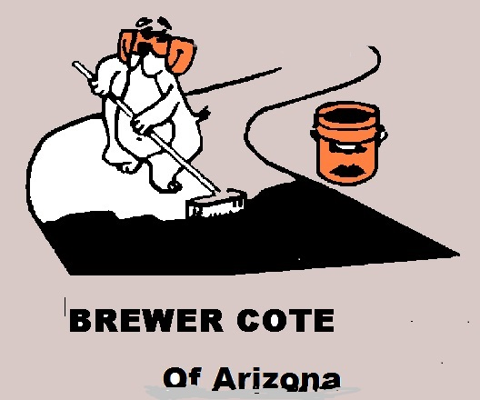
Brewer Cote of Arizona Hot Pour Loop Sealant SDS

Section 1: Identification
In this section you will find the product name which will be listed on the label as well as any contact information on the manufacturer.

Product Identification and Product Code
Product Use Description
Manufacturer/Supplier
Emergency Phone Number

Hot Pour Loop Sealant
430501A 34# Box
Asphalt Joint Filler

Brewer Cote of Arizona
5226 W Missouri Ave
Glendale AZ 85301
888-931-3728
CHEMTREC – 800-424-9300
Section 2: Hazard(s) Identification

When looking at the different classifications of hazards this chemical meets you will see category numbers to tell you how severe the hazard is.
Please remember, these numbers ARE NOT the same as the old NFPA/HMIS system. In this case, the numbering generally starts at 1 (most
hazardous) and ends at 5 (least hazardous.) There are letters used in certain categories as well. Always remember, the lower the number or letter,
the more severe the hazard.
O.S.H.A. Hazard Classifications:
Eyes Irritation- Category 2A
Skin Irritation- Category 4

US OSHA Hazard Symbol:


Signal Word: Warning!

US DOT SYMBOLS
Non Regulated

Hazard Statements: May be harmful if swallowed. May cause burns if contact with skin. Will cause eye irritation.
Page 1 of 5

Section 3: Composition/Information on Ingredients
This section lists the ingredients of this product. For Exposure limits please refer to section 8 of this document.

Component | CAS-No. | Weight
Asphalt Cement | 08052-42-4 | <50.00
Rubber | 2630-26-4 | <50.00
Extenders | NA Mixture | <30.00
Fillers | NA Mixture | <35.00
Section 4: First-Aid Measures
This area will tell you what to do if there is an exposure to this chemical. If there is an exposure situation that requires emergency care, remember to
bring a copy of this document to help in aid.

Inhalation:
Skin Contact:
Eye Contact:
Ingestion:

Remove from contaminated area. If breathing is difficult, give oxygen. If breathing stops, give
artificial respiration - Call Physician
Remove contaminated clothing. Cool with water, Remove with mineral, soap & water, get medical help for several burns
Immediately flush with water for at least 15 minutes holding eyelids open. Call a physician if irritation
develops
If conscious give 1 to 2 glasses of milk or water, induce vomiting and call a physician. NEVER GIVE
ANYTHING BY MOUTH TO AN UNCONSCIOUS PERSON.
Section 5: Fire Fighting Measures

This section lists how to extinguish a fire but more importantly any specific hazards that can be created should this product burn.

Suitable Extinguishing
Equipment:
Specific Hazards:
Special Protective Equipment:
Other Information: N/A

Dry chemical,C02, or standard foam.
Use self controlled breathing apparatus in enclosed areas & Full body protection gear including face shield, trench coat
Although this material is considered non-flammable, if it is in the fire area, an
approved, self-contained breathing apparatus should be worn to prevent exposure
to thermal decomposition products and residual monomers.
For fires in enclosed areas, wear self-contained breathing apparatus.
Page 2 of 5

Section 6: Accidental Release Measures
This section provides recommendations on the appropriate response to spills, leaks, or releases including containment and cleanup practices to
prevent or minimize exposure to people, properties, or the environment.

Personal Precautions:
Environmental
Precautions:
Methods for Clean Up:

Avoid prolonged inhalation. Open all windows and doors. Advise proper authorities.
Wear protective clothing, safety glasses, and impervious gloves.
Prevent product from entering storm drains, sewers.
Allow to cool and solidify cover with earth to reduce adhesiveness, place in appropriate containers for transporting to a waste disposal site
Section 7: Handling and Storage

This section provides guidance on the safe handling practices and conditions for safe storage of chemicals.

Precautions for Safe
Handling:
Conditions for Safe Storage:

Use only as directed in well ventilated area. Avoid prolonged contact with skin. Avoid
contact with eyes. Avoid breathing mist or vapors. Do not eat, smoke, or drink with
contaminated hands. Do not discard into sewers or drains.
Store away from ignition sources in tightly sealed containers at room temperature. Do
NOT store in Direct Sunlight.

Section 8: Exposure Controls/Personal Protection
This section indicates the exposure limits, engineering controls, and personal protective measures that can be used to minimize worker exposure.
OSHA Permissible Exposure Limits: N/A
Control Parameters: N/A
Recommendations for Personal Protection: Gloves, Eye Protection
Other Special Instructions: N/A
Page 3 of 5

Section 9: Physical and Chemical Properties
This section identifies physical and chemical properties associated with the substance or mixture.
Appearance- Black
Odor- Petroleum Order
pH- 3-4
Melting Point- N/A
Freezing Point - 32*F
Initial Boiling Point- 600*F
Flash Point- N/A
Evaporation Rate- Equivalent to Water
Flammability- Non Flammable
Explosive Limits- N/A
Vapor Pressure- N/A
Vapor Density- N/A
Solubility(ies)- NIL
Viscosity- 135+ KU's
Section 10: Stability and Reactivity
This section describes the reactivity hazards of the chemical and the chemical stability information. This section is broken into three parts: reactivity,
chemical stability, and other.
Reactivity: Avoid use around oxidizing agents.
Chemical Stability: Stable
Other:
Section 11: Toxicological Information
This section identifies toxicological and health effects information or indicates that such data are not available.
Non-Toxic
Section 12: Ecological Information (non-mandatory)
This section provides information to evaluate the environmental impact of the chemical(s) if it were released to the environment.
Bury in an approved waste dump area or burn in approved incinerator follow
Page 4 of 5
Section 13: Disposal Considerations (non-mandatory)
This section provides guidance on proper disposal practices, recycling or reclamation of the chemical(s) or its container, and safe handling practices.
Although this product is believed to have no adverse effects on the environment, ALWAYS dispose of unused material in
accordance with Federal, State and local laws.
Section 14: Transport Information (non-mandatory)
This section provides guidance on classification information for shipping and transporting of hazardous chemical(s) by road, air, rail or sea.
Class 55
Section 15: Regulatory Information (non-mandatory)
This section identifies the safety, health, and environmental regulations specific for the product that is not indicated anywhere else on the SDS.
Keep pallets intact until material is used to prevent container deterioration.
Section 16: Other Information
This section indicates when the SDS was prepared, when the last known revision was made and other useful information.
Prepared by Brewer Cote of Arizona
Printed Date: 7/28/2016
Disclaimer- Although careful consideration was exercised in the preparation of this document, some information was
obtained from external sources which we believe is reliable. However; the information provided is without warranty,
expressed or implied, regarding its accuracy or completeness.
Page 5 of 5

