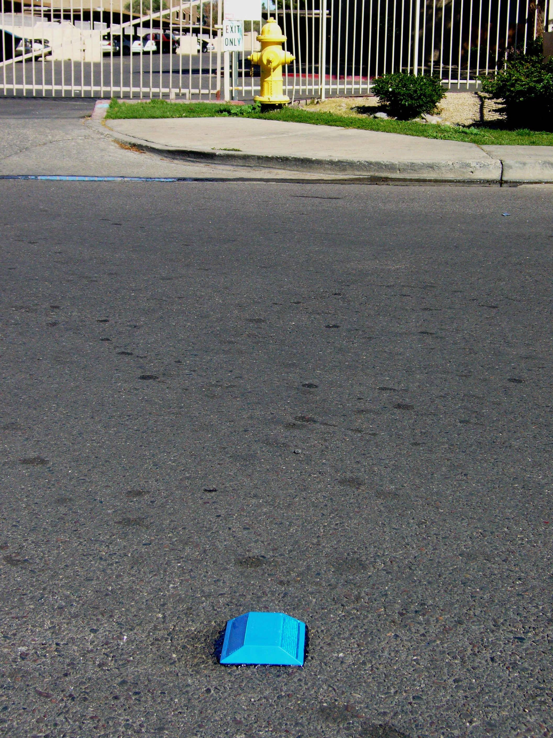

BREWER COTE® of Arizona
Pavement Marker Adhesive

DESCRIPTION:
Pavement Marker Adhesive is a hot melt adhesive for the placement of pavement markers. This product may be used to bond both ceramic and plastic markers to Portland cement concrete, asphaltic concrete, or chip-sealed road surfaces. It acts as a media between the marker of passing traffic and the thermal shock of temperature changes. Damage to the pavement surface is virtually eliminated and the life expectancy of the marker itself is extended. Composed of select asphaltic material blended with mineral filler.

Advantages:

- Permanent Bond

- Economical
- Long Lasting

- Can be used on Concrete or Asphalt
- No Mess
- Easy to Install

5226 W Missouri Ave Glendale AZ 85301 Phone: 888-931-3728 Fax: 623-842-0714 www.brewercoteaz.com
Pavement Marker Adhesive

Composition:
Pavement Marker Adhesive shall consist of a bottom release paper liner, a middle layer comprised of .93 mil thickness of non tracking, non shrinking rubberized asphaltic membrane and a top layer of a 3 mil clear plastic liner.

Method of Application:
Step 1 Contacting surface
Step 2
After removal of the white wax paper,
press the exposed side onto the surface
where the reflector is to be located

must be completely clean, dry
and free of foreign and loose
material. Pre-heat the ground
where the adhesive will
be placed.

Step 4 Immediately press device on softened Pad and allow cooling, to achieve maximum adhesion requires only a few minutes.

[Type a quote from the document or the
Step 3 Heat the top of the Quik Pad using a standard torch until pad is liquefied and the clear plastic is flashed off.

Packaging: Packs of 20 4” X 4”

Weather Limitations:
For best results, do not apply on rainy days or when the temperature is expected to drop below 50 degrees F during the next 24 hours. On hot days, the pavement shall be pre-dampened with fog system. New asphalt should not be sealed until after exposed to a full summer heat cycle. Ambient and surface temperature must be at least 55 F and rising during application. Do not apply if rain is in the forecast for the next 24 hours.

REV. 3/19

