 | Crack Sealant Tools
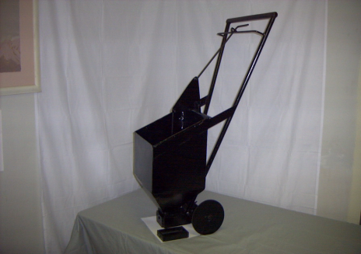 |  | Drag King  #488610  Rplc. Bottom Shoe  #488620 | 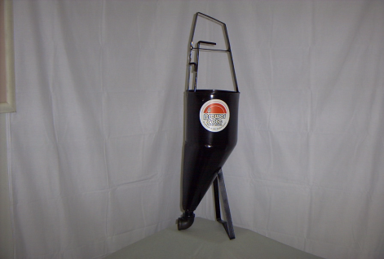 | Pour Pot  #488630

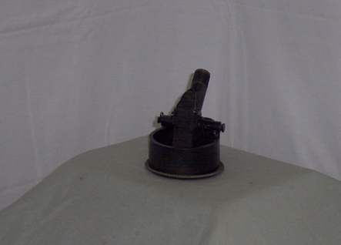 | Cracksealant Shoes  #488650 6” Shoe  w/valve tip  #488570 6” Shoe | 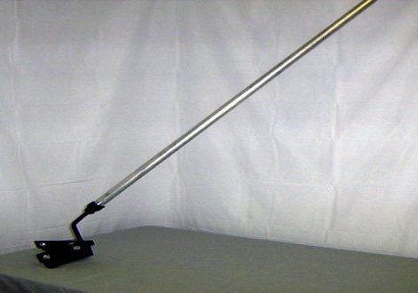- | Cracksealant Squeegee’s  PUSH OR PULL  (REVERSABLE HEAD)  w/ Aluminum 5’ Handle  #488500 Hi Temp

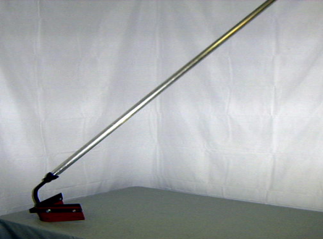 | Cracksealant  Squeegee’s PULL  w/ Aluminum 5’ Handle  #488520 Hi Temp  #488521 Neoprene  #488522 Gum | 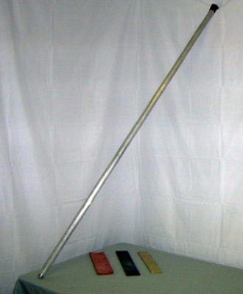 | Cracksealant Rplc Blades & Alum. 5’ Handle  #488530 Hi Temp  #488513 Large Blade  #488511 Large Hi Temp  #488501 5’ Handle

Check Out More Equipment On Our Website!
www.brewercoteaz.com

Glendale (623) 931-3728

Out of Area (888) 931-3728

