***OCIA REGISTRATION FORM***  
  
Name:________________________________________________________________________ First Middle Last

Physical Address:________________________________________________________________ Street City State Zip Code

Mailing Address:________________________________________________________________ City State Zip Code

Cell Number:____________________________ Email:__________________________________

Date of Birth:___________________________ / __________________ / ________________

Place of Birth: __________________________________________________________________ City State Zip Code

Father’s Name:_________________________________________________________________ First Middle Last

Mother’s Name:________________________________________________________________ First Middle Maiden Name

**Sacramental Information**

Have you been Bpatized? _______ YES _______ NO

If YES what religion?_____________________________________________________________

***If Yes please attach a copy of your baptismal certificate to this form***

If your were baptized Catholic, have you received either of the following Sacraments?

Confimation: _______ YES _______ NO

1st Holy Communion *(Reconciliation and Eucharist):* _______ YES _______ NO  
  
  
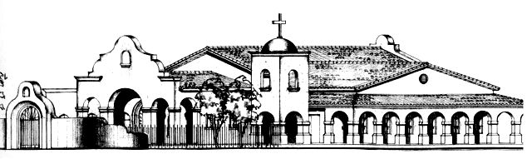

**Marital Status:** Please check all boxes that apply. If you are currently married, all previous marriages must be formally annulled by the Catholic Church in order to receive any Sacraments.

I have never been married.

I am married in the Catholic Church by a priest or a deacon.

I have never been married, but I am living in a relationship with a significat other.

I am married, but not in the Catholic Church.

I have been married more than once. I have a prior marriage.

My spouce has been married more than once. My spouse has a prior marriage.

Other, pleasew describe: _____________________________________________________

If you are married, what religion is your spouse? ______________________________________

______________________________________________________________________________ Name of Church

______________________________________________________________________________ City State Zip Code

I____________________________________ Verify that all I have answered is correcy and true. Name (please print)

_

_____________________________________________________ ______________________ Signature Date

**Office Use Only:**

________________________________________________________ ____________________ Interviewed by Date

Status (check one)

_______ Catechumen

_______Candidate for full Reception in to the Catholic Church

_______ Candidate for the Sacraments of Confirmation and 1st Holy Communion

_______ Candidate for the Sacrament of Confirmation only.

_______ Candidate for the Sacrament of First Holy Communion.

Name of Sponsor: ___________________________________________________________________________

Reffered to Priest; _______ YES _______ NO

**Pg. 2 of 2**