**St. Peter’s Catholic Church** P. O. Box 1566 Springerville, AZ 85938 (928) 333-4423 Webpage [www.stpeterchurchaz.com](http://www.stpeterchurchaz.com) Email [stpeterspringerville@dioceseofgallup.org](mailto:stpeterspringerville@dioceseofgallup.org) Facebook; StPeters Church

**Sponsor / Proxy**

Name: ____________________________________________________________________________________ First Middle Last

Physical Address: ___________________________________________________________________________ Street City Sate Zip Code

Mailing Address: ____________________________________________________________________________ P. O. City Sate Zip Code

Phone Numbers: ____________________________________________________________________________ Cell Home Work

Email (Optional): ____________________________________________________________________________

Place of Birth: ______________________________________________________________________________ City State Zip Code

Fathers Name: _____________________________________________________________________________ First Middle Last

Mothers Name: _____________________________________________________________________________ First Middle Maiden Last Name

Are you registered at St. Peter’s Parish? _______ YES _______ NO

If NO what Parish are you registered? ___________________________________________________________

If NO, an affidavit of sponsorship from your Parish MUST be attached to this form. *(Please Check all that apply)*

*_______* Sacrament ofBaptism

_______ 1st Holy Communion Sacrament of (Reconciliation and Eucharist)

_______ Sacrament of Confirmation

Are you Married? _______ YES _______ NO

If YES, was your current marriage in the Catholic Church by a priest or a Deacon? _______ YES _______ NO

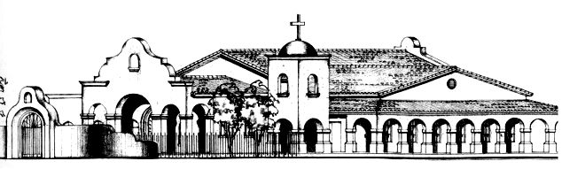 117 North Papago St.

Why do you want to be a Sponsor? Please describe: _______________________________________________

__________________________________________________________________________________________

__________________________________________________________________________________________

__________________________________________________________________________________________

__________________________________________________________________________________________

__________________________________________________________________________________________

__________________________________________________________________________________________

Have you ever been a sponsor before? _______ YES _______ NO

If YES, what Parish? __________________________________________________________________________

Are there any teachings of the Catholic Church which you disagree? Please describe: _____________________

__________________________________________________________________________________________

__________________________________________________________________________________________

__________________________________________________________________________________________

I, ________________________________________________ verify that all I have answered is correct and true Please print your name

____________________________________________________________ __________________________ Signature Date

**FOR OFFICE USE ONLY**

Meeting with RCIA Director: _______

Application Accepted: _______

Application Rejected: ______

__________________________________________________ ___________________________________ Candidate or Catechumen Assigned Sponsoring an Adult or a Child

Pg. 2 of 2