**St. Peter’s Catholic Church** P. O. Box 1566 Springerville, AZ 85938 (928) 333-4423 Webpage [www.stpeterchurchaz.com](http://www.stpeterchurchaz.com) Email [stpeterspringerville@dioceseofgallup.org](mailto:stpeterspringerville@dioceseofgallup.org) Facebook; StPeters Church

**O.C.I.A.**

**OCIA:** *The Order of Christian Initiation of Adults* is a process through which adults and children are instructed to learn about the Catholic Faith and are welcomed and received into the Catholic Church at the Easter Vigil Mass.

If you or someone you know is interested in becoming a Catholic, or if you want to learn more about your faith please fill out ther following form and either mail it, email it or drop it off at the Parissh Office.

**Name:**________________________________________________________________________

**Phone:**________________________________________________________________________

**_______** I would like to know more about OCIA.

**_______** I am interested / thinking about becomingf a Catholic.

**_______** I definithly want to become a Catholic.

**_______** I am Catholic, though baptized but have not yet received

1st Holy Communion (Eucharist) and or Confirmation.

**_______** I am Catholic, but would like to learn more about my faith.

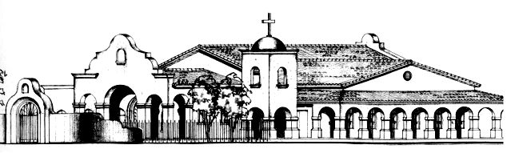 117 North Papago St.