**Quinceañera**

**Name:** _______________________________________________________ **Date:** ___________________

**Date of Birth** __________________________________________________________

**Please provide proof of the following sacraments: Baptism**, **1st Holy Communion**, & **Confirmation**

**Mass Attendance: Weekly**_______________ **Occasionally**______________ **Never**_______________

**Father’s Name:** ______________________________________ **Religion:** _________________________

**Mother’s Name:**______________________________________ **Religion:** _________________________

**Current Mailing Address:** ________________________________________________________________

**Name of Contact Person:**________________________________ **Cell** **#:**___________________________

**Nombre del Chamberlan:**________________________________________________________________

**Number of participants in the Quinceañera:**_________________________________________________

**Confessions Quinc****eañera:**____________________ **Confessions for Participants:**___________________

**Celebrant:**____________________________________________________________________________

**Stole Fee $50.00:**___________________ **Cash:**___________________ **Check #:**____________________

**Rehersal Date:**____________________________________ **Time:**________________________________

**Quinceañera Mass Date:**____________________________ **Time:**_______________________________

**NOTE: ABSOLUTLY NO GLITER ALLOWED IN CHURCH**

**I understand and agree with the above guidelines**

**Parent Signature:**__________________________________________ **Date:**_______________________

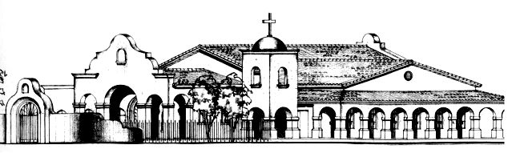 117 North Papago St.