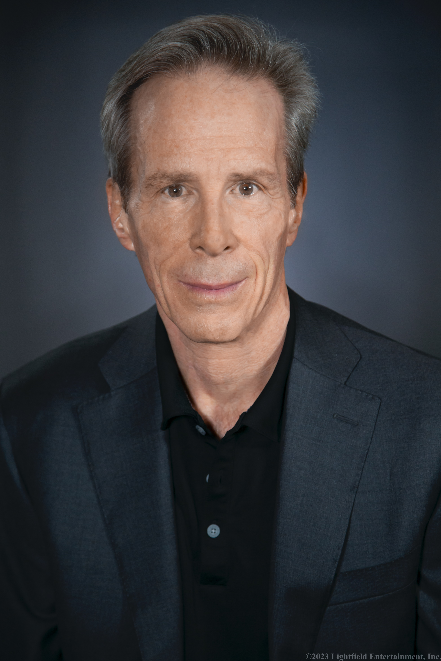

ED GLYNN ACTOR

CONTACT PADRAIC CONFREY

646-420-0037

[Padraic@JCWilliamAgency.com](mailto:Padraic@JCWilliamAgency.com)

AEA, SAG

New York & Los Angeles

Role Types: Caucasian, 45-70

**Credits:**

**Film**

Short Emily Business Owner Haruko Productions NY,NY

Short Shopkeeper Harlem: Town Hall The 54th Filmworks NY,NY

Short Father (Lead) Hokkaido Haruko Fujimoto Prods. NY,NY

Short James (Co-Lead) Reservation Kristine Lee Morgan Prods. NY,NY

Short Nick Appelman The Book of Hannah Greneland Films NY,NY

Short Mr West Thinking of The West More Like This Prods. Jersey City,NJ

Short Tom (Co-Lead) Nail In The Coffin Lost Sunshine Prods. Madison,NJ

Feature John Featherstone The Dirty Kind Vitelloni Prods., Inc NY,NY

Short Warren Nichols (Lead) Weight of the Pen Always Write Prods. NY,NY

Feature Sam Everyone Knows McGee Andrew McCardle Films Brooklyn,NY

Feature Stanley He Belongs To Us Look At The Wall Prods. NY,NY

Short Angus Tuck Tuck Everlasting by Sam Potochick NY,NY

Short Charlie Stiff Nicholas Calisti Montclair,NJ

**Plays**

Thomas No Soap George Productions Hudson Guild Theatre NY,NY

Congressman Bingham Victoria Woodhull Theater For The New City NY,NY

Priest The Hour GetWrite Entertainment Jersey City,NJ

District Attorney Second Seat Audacity Innovative NY,NY

(2016 Winner of Best Play at Venus Adonis Film Festival, Hudson Guild Theatre)

Edward R. Murrow Angie Jackson Vincent Key Productions Jersey City,NJ

**Television**

Thomas Jefferson Mysteries of The Museum, D1 Season 16 Optomen Prods. NY,NY

Paskiel’s Brother Shattered, 101 Episode Discovery Channel

Red Marble Media Brooklyn,NY

**Commercials**

NY Supplemental Healthcare Insurance Barber Sameer Films NY,NY

Pancreatic Cancer PSA Runner Studio Center White Plains,NY

**Education & Training**

Stella Adler Studio

-Scene Study I & I J. Claude Deering, Los Angeles

-Sound Into Action Workshop Nicole Cowans, Los Angeles

-Acting Technique Josh Davis , NY, NY

-Film & TV Alberto Bonilla NY, NY

-Lee Strasberg Method Acting Claire Alexander NY, NY

-Shakespeare Without Fear Workshop, Jack Cornell, Jeff Hardy, Jennifer Yadov

-Lehigh University

-Dialects: Irish, British, French, German, Italian, Brooklyn, Southern USA

-Soccer, golf, tennis, swimming, running, baseball