CALL TO ACTION! WE NEED YOUR VOICE LEHI.

Important Background Information:
The Price property is located on Center Street, south of the ADOT Basin. It was historically a part of Lehi and is still considered a ‘Fringe Area.’ It is 8.2 Acres and is currently being used as a Horse Stables and Single-family residential parcel. The current zoning is RS-43; 1 home per acre.
The developer is proposing to change the zoning from RS-43 to RM-2 which is a MULTIFAMILY high density zoning. This would allow 10.7 Townhomes per Acre. They are proposing 88 Townhomes that are 3-4 bedrooms each.

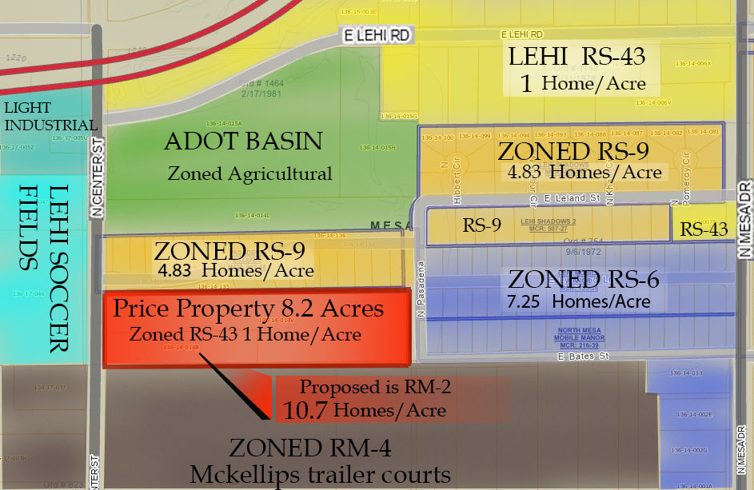

RS-43 | 1 HOME/ACRE (Lehi’s current zoning)
RS-9 | 4.83 HOMES/ACRE (Lehi shadows)
RS-6 | 7.25 HOMES/ACRE
RM-4 | TRAILER COURTS ALONG MCKELLIPS
RM-2 | PROPOSED DENSITY AT 10.7 HOMES/ACRE

We need EVERY resident in Lehi to review the proposed development and decide if this project fits with the surrounding areas and does it support or detract from our Lehi Community and lifestyle; then voice your opinion. This is TIME SENSITIVE!
See back page for who to contact.

Here are some concerns brought up by residents:

1. Increased Traffic due to higher density
- Single family zoning (RS) is standard in our neighborhood. There are concerns with allowing Multifamily zoning (RM) and how it may impact our rural lifestyle
- The current design shows only one entrance/exit on Center Street, forcing more traffic on Lehi Road when residents make a right turn to exit the property. A second entrance/exit is needed on the east end.

2. Equestrian Safety and Accessibility to Local trails
- Large numbers of horses access the river on Center Street. Adding high numbers of residential vehicles in addition to Soccer field traffic may restrict access
- Large increases in traffic through Lehi will increase probability of Equestrian accidents

3. Compatibility/Lifestyle Conflict
- Suburban 'condo' lifestyle has different preferences than Rural/Agricultural Lifestyles. Conflicts may arise such as: Smells of surrounding areas with livestock, dangers with cattle or other livestock getting loose, and other city vs rural preferences and expectations.
- This area is defined as a ‘Fringe Area’ of Lehi; a buffer zone. Adding dense urban lifestyle may add pressure to Lehi’s rural way of life.

4. Concerns for Future Impact with regard to road use
- Added pressure to install lights or other traffic controls to accommodate increased traffic in the future.
- Fire and emergency vehicle use through Lehi.

5. Lehi's public areas have limitations
- Lehi does not have a formal public park so public spaces are limited to road shoulders. Adding a high number of people walking, biking daily may eventually necessitate unwanted infrastructure such as sidewalks or lights.
- Lehi has consistently opposed having sidewalks or street lights. If the limited public spaces reach carrying capacity and create safety issues, it may become necessary to add infrastructure previously identified as 'not with character of Lehi'

6. Loss of Stables and ‘Equine way of Life’
  - Other options are possible with 8.2 acres. Developments compatible with the area may be single family homes, or equestrian oriented homes rather than multifamily Townhomes.
  - Losing a horse boarding area of such great size creates additional pressure for Lehi to absorb the horses.
  - Contributes to an overall loss of equine facilities and 'way of life' that is unique to Lehi.

PLEASE EMAIL COUNCILMEMBER FREEMAN AND THE LAWYER FOR THE DEVELOPER ASAP!
Councilmember.freeman@mesaaz.gov
Sean.lake@pewandlake.com

Hopefully, you also received an email from the Lehi Community Board on this project. If you did NOT, please send your name, email and phone number to info@lehicommunityAZ.org so we can add you to our communication data base. You can also use that email address to communicate directly to the Lehi Community Improvement Association Advisory Board at any time.

Check out our website at www.LehiCommunityAZ.org for updates to this and other events impacting our community.

