RESOLUTION NO. 2022-07-11-002
A RESOLUTION ACCEPTING THE ATTACHED 2023 TAX BUDGET TO BE SUBMITTED TO THE DARKE COUNTY AUDITOR FOR CONSIDERATION OF THE DARKE COUNTY BUDGET COMMISSION AND DECLARING AN EMERGENCY.

WHEREAS, the Council of the Village of Wayne Lakes needs to adopt a 2023 tax budget to submit to the Darke County Auditor before July 15, 2022 per O.R.C. 55705.28; and
WHEREAS, the Village of Wayne Lakes has prepared and reviewed the Budget attached hereto as Exhibit A.
NOW, THEREFORE, BE IT RESOLVED by the Council for the Village of Wayne Lakes, Darke County, Ohio, two-thirds (2/3) of all members thereto concurring, that;
SECTION ONE: The Village of Wayne Lakes hereby authorizes and accepts the 2023 Tax Budget attached hereto as Exhibit A.
SECTION TWO: Two (2) copies of the Budget attached hereto for the fiscal year beginning 01/01/2023 (Exhibit A) shall be submitted to the Darke County Auditor for the consideration of the Darke County Budget Commission on or before July 15, 2022.
SECTION THREE: This Resolution is hereby declared to be an emergency measure necessary for the immediate preservation of the public health and safety of the residents of the Village of Wayne Lakes; therefore, this Resolution shall be in full force and effect from and immediately after its passage.
Passed this 11th Day of July, 2022.
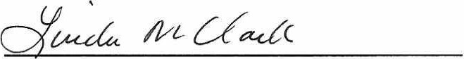
Linda M. Clark, Mayor ATTEST:
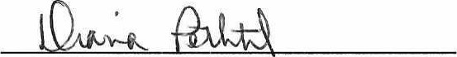
Diana Pethtel, Fiscal Officer
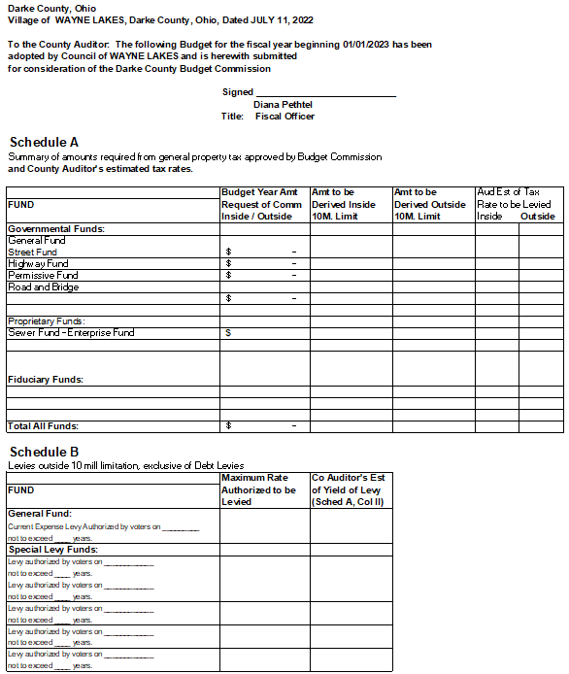

STATEMENT OF FUND ACTIVITY
Fund Name: General Fund
Description | 2022 | 2023
 | Current Year | Budget Year
 | Estimate | Estimate
Revenues:
Property Taxes (Real & Personal) | $110,500.00
Requested Local Gov't Money
Other Revenues | $172,000.00
Total Revenues | $282,500.00 | $0.00
Total Expenditures
Revenues over (under) Expenditures | $282,500.00 | $0.00
Beginning Cash Balance |  | $282,500.00
Ending Cash Balance | $282,500.00 | $282,500.00
Encumbrances at year end
Fund Name: Street Fund
Description | 2022 | 2023
 | Current Year | Budget Year
 | Estimate | Estimate
Revenues:
Property Taxes (Real & Personal)
Other Revenues | $57,756.00
Total Revenues | $57,756.00 | $0.00
Total Expenditures | $48,200.00
Revenues over (under) Expenditures | $9,556.00 | $0.00
Beginning Cash Balance | $142,851.45 | $152,407.45
Ending Cash Balance | $152,407.45 | $152,407.45
Encumbrances at year end
Fund Name: Highway Fund
Description | 2022 | 2023
 | Current Year | Budget Year
 | Estimate | Estimate
Revenues:
Property Taxes (Real & Personal)
Other Revenues | $4,100.00
Total Revenues | $4,100.00 | $0.00
Total Expenditures | $2,900.00
Revenues over (under) Expenditures | $1,200.00 | $0.00
Beginning Cash Balance | $22,136.70 | $23,336.70
Ending Cash Balance | $23,336.70 | $23,336.70
Encumbrances at year end
Fund Name: Permissive Fund
Description | 2022 | 2023
 | Current Year | Budget Year
 | Estimate | Estimate
Revenues:
Property Taxes (Real & Personal)
Other Revenues | $2,101.00
Total Revenues | $2,101.00 | $0.00
Total Expenditures | $1,200.00
Revenues over (under) Expenditures | $901.00 | $0.00
Beginning Cash Balance | $4,405.68 | $5,306.68
Ending Cash Balance | $5,306.68 | $5,306.68
Encumbrances at year end
Fund Name: Road and Bridge Levy
Description | 2022 | 2023
 | Current Year | Budget Year
 | Estimate | Estimate
Revenues:
Property Taxes (Real & Personal)
Other Revenues | $22,877.00
Total Revenues | $22,877.00 | $0.00
Total Expenditures | $16,495.00
Revenues over (under) Expenditures | $6,382.00 | $0.00
Beginning Cash Balance | $74,041.72 | $80,423.72
Ending Cash Balance | $80,423.72 | $80,423.72
Encumbrances at year end
Fund Name: Capital Fund - Sewer
Description | 2022 | 2023
 | Current Year | Budget Year
 | Estimate | Estimate
Revenues:
Property Taxes (Real & Personal)
Other Revenues | $300,000.00
Total Revenues | $300,000.00 | $0.00
Total Expenditures | $223,339.50
Revenues over (under) Expenditures | $76,660.50 | $0.00
Beginning Cash Balance |  | $76,660.50
Ending Cash Balance | $76,660.50 | $76,660.50
Encumbrances at year end
Fund Name: Sewer Operating Fund
Description | 2022 | 2023
 | Current Year | Budget Year
 | Estimate | Estimate
Revenues:
Property Taxes (Real & Personal)
Other Revenues | $108,000.00
Total Revenues | $108,000.00 | $0.00
Total Expenditures | $7,560.00
Revenues over (under) Expenditures | $100,440.00 | $0.00
Beginning Cash Balance | $66,500.00 | $166,940.00
Ending Cash Balance | $166,940.00 | $166,940.00
Encumbrances at year end

