**VILLAGE OF WAYNE LAKES**

**REGULAR COUNCIL MEETING**

**Village Office Building**

**1052 MAIN ST.**

**May 7, 2024**

Mayor Linda M. Clark called the meeting to order at 07:00PM. Roll call was taken. Council members present: Susan Hyatt, Johna Wathen, Robert Ewry and Cynthia Wion. Laura Price excused absence. No visitors attended the meeting.

**Agenda**: Ewry moved to approve the agenda, as submitted by the Mayor. Wathen seconded. All present voted yea.

**Minutes:** None submitted for approval.

**Financial Report:** None submitted for approval.

**Executive Session:**

Wathen motioned to move into Executive Session, Hyatt seconded. All present voted yea.

O.R.C. Section 121.22 (G)(3)

Hyatt motioned to return from Executive Session, Ewry seconded. All present voted yea.

Motion made by Ewry to adjourn the meeting. Seconded by Wion. All present voted yea. Meeting adjourned at 08:35PM.

Respectfully submitted by

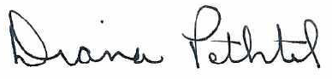

Diana Pethtel, Fiscal Officer