**Grand Ballet Vancouver**

**Beauty through the Movement….**

**Calendar *2021/2022 Season***

Updated on March 31 2021

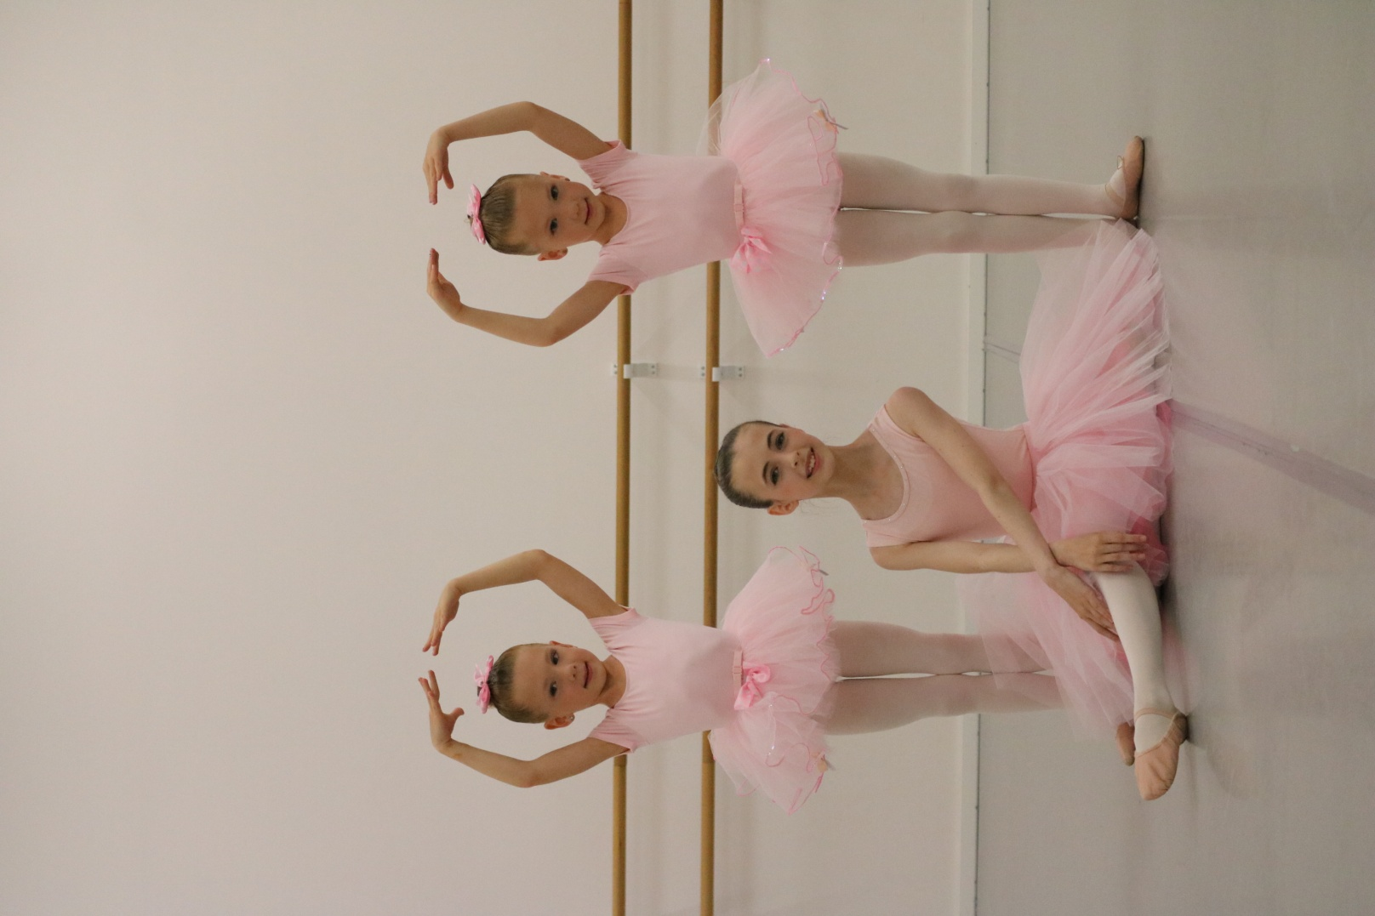

- Sep 7 1st Day of Class

- Oct 11 Thanksgiving Day (Academy closed)

- Nov 11 Remembrance Day (Academy closed)

- Dec 11~18 Viewing Week

- Dec 20~Jan 3 Winter Vacation

- Jan 4 Academy Re-opens

- Feb 21 Family Day (Academy closed)

- March 14-26 Spring Break

- April 15~18 Good Friday and Easter Break

- May 23 Victoria Day (Academy closed)

- June 4-5 Year- End performance (SCOTIABANK Dance Center)

- June 18 Last Day of Class

- Jul/Aug Summer Dance Camp (TBA)

**2503 Kingsway, Vancouver / Tel:** [**778-379-7113 / info@grandballetvancouver.com**](mailto:778-379-7113%20/%20info@grandballetvancouver.com) **www.grandballetvancouver.com**