**Grand Ballet Vancouver**

**Beauty through the Movement….**

**Calendar *2022/2023 Season***

Updated on August 1, 2022

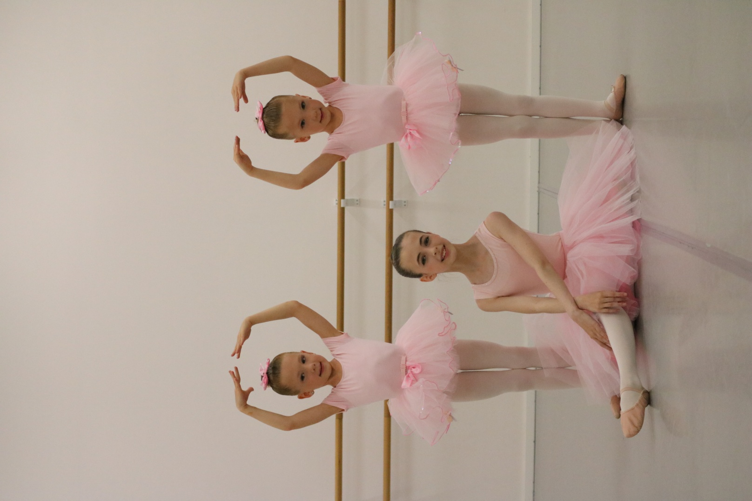

- Sep 6 1st Day of Class

- Oct 10 Thanksgiving Day (Academy closed)

- Nov 11 Remembrance Day (Academy closed)

- Dec 5~17 Viewing Week

- Dec 19~Jan 2 Winter Vacation

- Jan 3 Academy Re-opens

- Feb 20 Family Day (Academy closed)

- March 13-25 Spring Break

- April 7~10 Good Friday and Easter Break

- May 22 Victoria Day (Academy closed)

- June 3 Year- End performance (SCOTIABANK Dance Center)

- June 17 Last Day of Class

- Jul/Aug Summer Dance Camp (TBA)

**2503 Kingsway, Vancouver / Tel:** [**778-379-7113 / info@grandballetvancouver.com**](mailto:778-379-7113%20/%20info@grandballetvancouver.com) **www.grandballetvancouver.com**