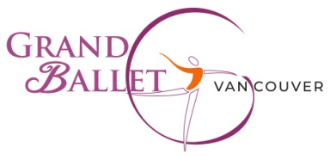
Dance Box (604) 936-7615
Cariboo Shopping Center, 435D North Rd. Coquitlam V3K 3V9

Pre-Ballet 1 (ages 5-6)
- Bodysuit: Light pink square neck - Ainsliewear AW102G Camio Pink
- Tights: Mondor 310 Ballerina Pink
- Shoes: Bloch full sole leather (S0205)
- Sweater: Light pink wrap *-*optional but encouraged*-*Capezio CK10949C (PNK)
- Pink rhinestone bun cover
Pre-Ballet 2 (ages 6-7)
- Bodysuit: Lavender square neck - Ainsliewear AW102G Lavender
- Tights: Mondor 310 Ballerina Pink
- Shoes: Bloch full sole leather (S0205)
- Sweater: Light pink wrap *-*optional but encouraged* -*Capezio CK10949C (PNK)
- Lavender rhinestone bun cover
Ballet 1 (ages 8-9)
- Bodysuit: Breeze square neck - Ainsliewear AW102G Breeze (light blue)
- Tights: Mondor Ballerina Pink
- Shoes: Bloch full sole leather (S0205)
- Sweater: Light pink wrap *-*optional but encouraged* -*Capezio CK10949C (PNK)
- Light blue rhinestone bun cover
Ballet 2 (ages 9-11)
- Bodysuit: Cobalt square neck - Ainsliewear AW102G Cobalt
- Tights: Mondor Ballerina Pink
- Shoes: Bloch full sole leather (S0205)
- Sweater: Pink wrap *-*optional but encouraged*-*Capezio CK10949C (PNK)
Junior (ages 10 -13)
- Bodysuit: Periwinkle spaghetti strap - Ainsliewear AW103 Periwinkle
- Tights: Mondor Ballerina Pink
- Shoes: Bloch full sole leather (S0205)

Pre-Professional (Ages 14 and over: As per teacher’s specifications)

Grand Ballet Vancouver 2503 Kingsway Vancouver, BC, V5R5H1 (778) 379-7113

