Dance Box (604) 936-7615 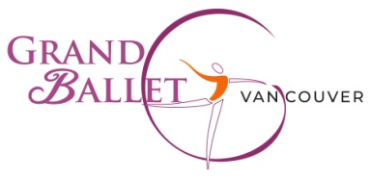
Cariboo Shopping Center, 435D North Rd. Coquitlam V3K 3V9
Pre-Ballet 1 (ages 5-6)
- Bodysuit: Light pink square neck
  - Ainsliewear AW102G Camio Pink
- Tights: Mondor 310 Ballerina Pink
- Shoes: Bloch full sole leather (S0205)
- Sweater: Light pink wrap **optional but encouraged**
  - Capezio CK10949C (PNK)
Pre-Ballet 2 (ages 6-7)
- Bodysuit: Lavender square neck
  - Ainsliewear AW102G Lavender
- Tights: Mondor 310 Ballerina Pink
- Shoes: Bloch full sole leather (S0205)
- Sweater: Light pink wrap **optional but encouraged**
  - Capezio CK10949C (PNK)
Ballet 1 (ages 8-9)
- Bodysuit: Breeze square neck
  - Ainsliewear AW102G Breeze (light blue)
- Tights: Mondor Ballerina Pink
- Shoes: Bloch full sole leather (S0205)
- Sweater: Light pink wrap **optional but encouraged**
  - Capezio CK10949C (PNK)
Ballet 2 (ages 9-11)
- Bodysuit: Cobalt square neck
  - Ainsliewear AW102G Cobalt
- Tights: Mondor Ballerina Pink
- Shoes: Bloch full sole leather (S0205)
- Sweater: Pink wrap **optional but encouraged**
  - Capezio CK10949C (PNK)
Junior – Beginner (ages 10 -12)
- Bodysuit: Periwinkle spaghetti strap
  - Ainsliewear AW103 Periwinkle
- Tights: Mondor Ballerina Pink
- Shoes: Bloch full sole leather (S0205)
Junior – Intermediate (ages 11-13)

- Bodysuit: Teal spaghetti strap
  - Ainsliewear AW103
- Tights: Mondor Ballerina Pink
- Shoes: Bloch full sole leather (S0205)

Ages 14 and over: As per teacher’s specifications

Grand Ballet Vancouver 2503 Kingsway Vancouver, BC, V5R5H1 (778) 379-7113

