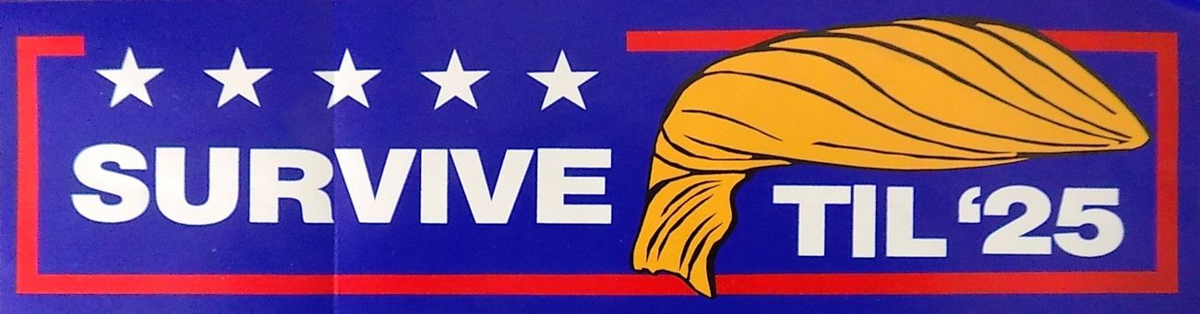

PRESS RELEASE Contact: Eugene R. Dunn
FOR IMMEDIATE RELEASE (631) 317-7551
March 3, 2021 SurviveTil25.com
SurviveTil25@survivetil25.com

UNIQUE WEBSITE KEEPS HOPE ALIVE FOR TRUMP 2024 RUN

Medford, NY – To fill the void of millions of despondent Trump supporters, a Long Island family has established a new website entitled, “SurviveTil25.com.” It is headed by Long Island-native Eugene Dunn, who has followed Trump’s career since a chance run-in at the opening of Central Park’s Wollman Rink in 1986. Dunn’s 16-year-old son, who serves as the web site’s technical advisor, has been an avid Trump fan since the day he left school early to watch Trump cascade down the escalator of Trump Tower to announce his presidential run.

The website will feature Trump updates and original op-ed pieces by Dunn, who is a conservative blogger and newspaper contributor. It will also feature the sale of the original “Survive til ’25” bumper sticker, with 50 percent of the net profits going directly to President Trump’s Super PAC or his yet-to-be-established 2024 campaign fund. The website store is expected to branch out into other campaign items such as tee shirts, hats, banners, etc. “Every item sold will be a grass roots contribution towards President Trump’s campaign war chest,”
said Dunn.

“It’s become abundantly clear that the American working class is in for a brutal four-year reversal of all of President Trump’s ‘America First’ gains, so I instinctively went into survival mode,” said Dunn, who claims to have been President Trump’s first financial contributor for the 2016 campaign. “Survive til ’25 is a slight variation of a term that Trump himself coined 30 years earlier--'Survive til ‘95’--which he used as his entrepreneurial battle cry en route to his launching the greatest comeback in American business history in the 1990s.”

“Just as millions of Make America Great Again bumper stickers littered the American landscape the last six years, Survive til ’25 will serve as a transitional message of hope to the 75-100 million Trump voters to hang on because help is just one presidential election away,” said Dunn. “President Trump did it before as the greatest turnaround POTUS in American history,” continued Dunn. “And I’m supremely confident he’ll do it again!”

