Shri Mallikarjun Jana Seva Society, Belagavi
Shri Mallikarjun Senior Citizens Home, Belagavi

Beneficiary Details
01-04-2022 to 30-09-2022

Sl. No. | Name | Gender | Age | APR-2022 | MAY-2022 | JUN-2022 | JUL-2022 | AUG-2022 | SEP-2022 | Health Condition | Photograph
1 | Kallappa Parashuram Patil | Male | 66 |  |  |  |  |  |  | Healthy | 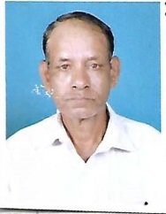
2 | Kashavva Adiveppa Hidaduggi | Female | 78 |  |  |  |  |  |  | Healthy | 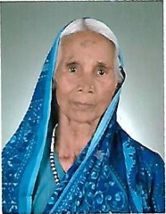
3 | Basappa Veerabhadrappa Lingoji | Male | 91 |  |  |  |  |  | X | Healthy | 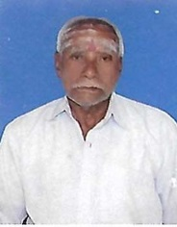
4 | Pushpa Ramchandra Jadhav | Female | 78 |  |  |  |  |  |  | Healthy | 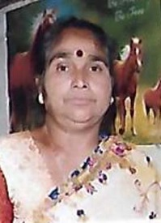
5 | Sunanda Balakrishna Undale | Female | 64 |  |  |  |  |  |  | Healthy | 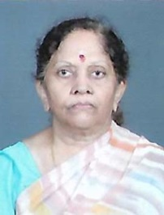
6 | Jayashri Gururaj Desai | Female | 69 |  |  |  |  |  | X | Healthy | 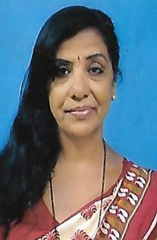
7 | Lingappa P. Yadiyur | Male | 69 |  |  |  |  |  |  | Healthy | 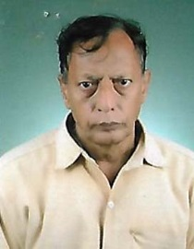
8 | Sushila Basappa Ambi | Female | 72 |  |  |  |  |  |  | Healthy | 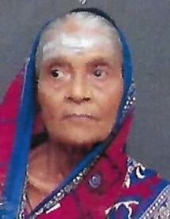
9 | Bhimavva Babu Vajantri | Female | 63 |  |  |  |  |  |  | Healthy | 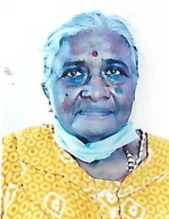
10 | Maruti Satyappa Manai | Male | 65 |  |  |  | X | X | X | Healthy | 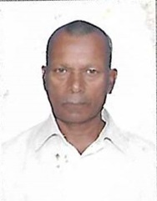
11 | Vijaya Krishna Kulkarni | Female | 65 |  |  |  |  |  |  | Healthy | 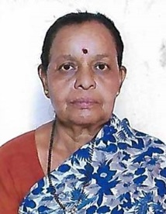
12 | Vishnu Amrut Mahendrakar | Male | 86 |  |  |  |  |  |  | Healthy | 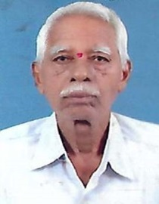
13 | Kalavati Gurunath Kulkarni | Female | 69 |  |  |  |  |  | X | Healthy | 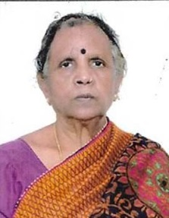
14 | Kasturi Yanappa Ediger | Female | 65 |  |  |  |  |  |  | Healthy | 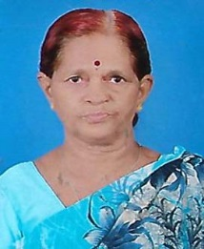
15 | Balakrishna Dattu Nesarikar | Male | 82 |  |  |  |  |  |  | Healthy | 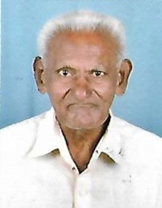
16 | Promod Bagwan Nagolkar | Male | 72 |  |  |  | X | X | x | Healthy | 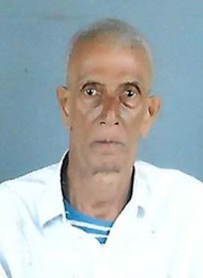
17 | Yellappa Basappa Muttennavar | Male | 62 |  |  |  | X | X | X | Expired on 24-06-2022 | 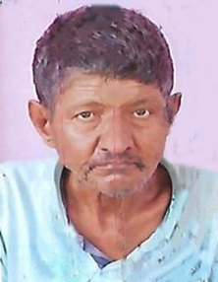
18 | Ratnavva Devappa Jakkannavar | Female | 74 |  |  |  |  |  |  | Healthy | 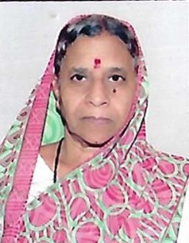
19 | Uma Manohar Sutakatti | Female | 71 |  |  |  | X | X | X | Healthy | 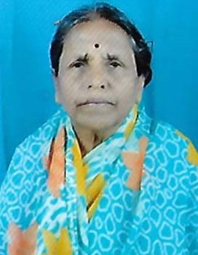
20 | Ningappa Mallappa Kyasti | Male | 67 |  |  |  |  |  |  | Healthy | 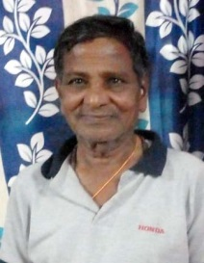
21 | Basalingayya Irayya Hiremath | Male | 76 |  |  |  | X | X | X | Left the institution | 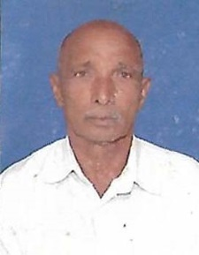
22 | Mohammadgous M. Pitaliwale | Male | 64 |  |  |  |  |  |  | Healthy | 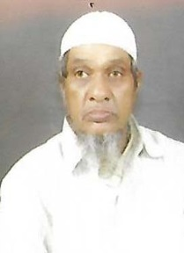
23 | Mallikarjun Siddaverappa Bellad | Male | 67 |  |  |  |  |  |  | Healthy | 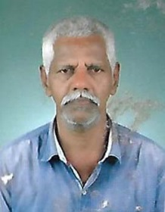
24 | Shrishail Firojappa Upari | Male | 77 |  |  |  |  |  |  | Healthy | 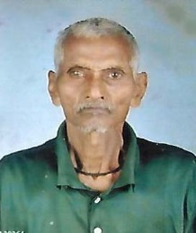
25 | Gulabi Chabbu Pujari | Female | 62 |  |  |  |  |  |  | Healthy | 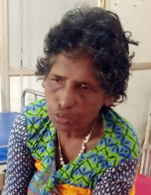
26 | Ashok Gangadhar Halakatti | Male | 68 | X |  |  |  |  |  | Healthy | 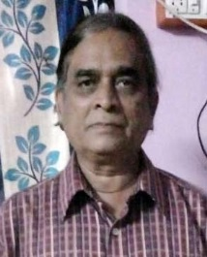
27 | Pramod Konappa Supali | Male | 69 | X | X | X |  |  |  | Healthy | 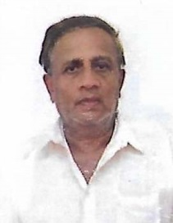
28 | Vishnu Rudrappa Sutar | Male | 61 | X | X | X |  |  | X | Left the institution | 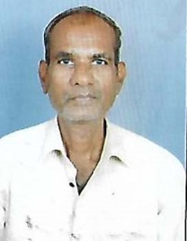
29 | Manik Ramchandra Ghorpade | Male | 69 | X | X | X |  |  |  | Healthy | 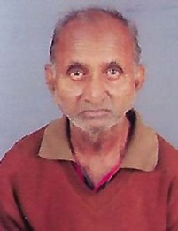
30 | Gurusiddappa Basalingappa Toggi | Male | 67 |  |  |  |  |  |  | Healthy | 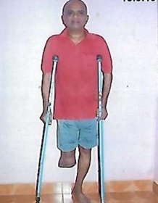
31 | Krishnabai Balachandra Bandekar | Female | 77 | X | X | X | X | X |  | Healthy | 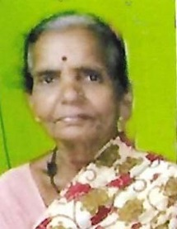
32 | Vivek Narayan Nakadi | Male | 67 | X | X | X | X | X |  | Healthy | 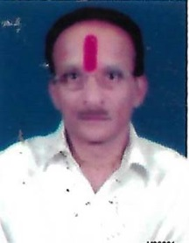
33 | Mallavva Basappa Tuppad | Female | 75 | X | X | X | X | X |  | Healthy | 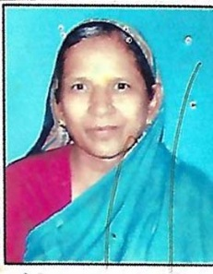
34 | Tulasabai Narayan Babanvachi | Female | 74 | X | X | X | X | X |  | Healthy | 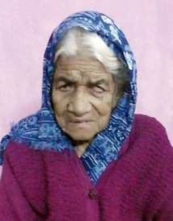
35 | Ninguli Bhimappa Patil | Male | 70 | X | X | X | X | X |  | Healthy | 