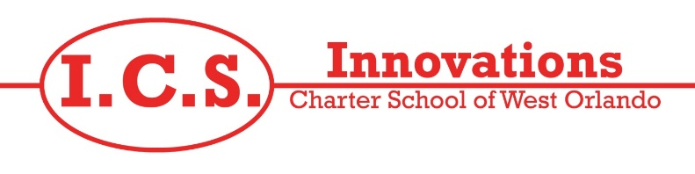

October 17, 2024

Dear Parents:

Your child’s teacher, Alona Ethington is a fully certified teacher in the State of Florida. She has earned a Bachelor’s Degree in History from Brigham Young University.

Ms. Ethington is currently certified to teach History and Language Arts and is completing the requirements for ESOL certification. Since she was the applicant that best meets the needs of our students and the school, the Orange County School Board has approved her to teach out-of-field. As a condition of this approval, she will be taking six (6) semester hours of college credit toward full certification in ESOL during the year. This placement is in compliance with our accreditation agency, the Southern Association of Colleges and Schools (SACS), and notification to parents is required by Section 1012.42 (2), Florida Statutes.

As a result of Alona Ethingtons’ background and expertise, she is well qualified to teach your child’s class.

Sincerely,

Patricia Lightner

Dr. Patricia A Lightner
Executive Director

