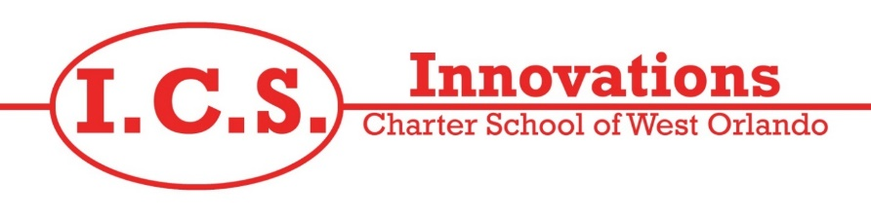

**November 1st – 5th, 2021**

**Monday**

Meatballs subs with Corn, mixed fruit, and milk.

**Tuesday**

Cheeseburgers with French fries fruit, and milk.

**Wednesday**

Corndogs with Veggie straw, pineapple fruit,

and milk.

**Thursday**

Hot pockets with String beans, mixed fruit, and milk.

**Friday**

Chicken nuggets with mixed veggies and mixed fruit, and milk.