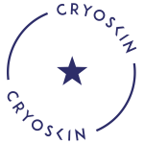
What to Expect:
- Manage your expectations.
  - Cryoskin alone will not radically change the shape of your body.
  - Cryoskin is designed to help manage areas of stubborn body fat and areas of dimpled skin or cellulite.

- If you are 35+ years old or 35+ inches or more around your tummy, your body may require more sessions to get your desired results.

- The better you are at creating and maintaining a healthy lifestyle, the better results you are likely to achieve.

