Consultation Form
Basic Information
First Name: _________________________ Last Name: ______________________ DOB: ___________

Treatment History
1. Have you ever tried any other aesthetic procedures in the past? Yes No
2. If “yes”, which ones?_________________________________________________________________
3. How did you hear about Cryoskin?
Friend/Family TV/Radio Internet Other: ____________________________________

Background Information (please check all that apply)
Botox in the past 30 days Fillers in the past 90 days
Surgery in the past 6 months Implants in the desired treatment area
Pregnant and/or breastfeeding Active/Past Cancer
Kidney and/or Liver disease Cardiovascular Disease
Lymphatic disorders Uncontrolled Diabetes
Sever allergy to cold Severe Raynaud’s Syndrome
Eczema, rashes, or dermatitis Open or infected wounds
Circulatory disorders Pacemaker/metal implants
Mesh inserts Incision scar(s) in the desired area
HIV/AIDS Body piercings in the desired area
Using topical antibiotics Lower Limb Ischemia
Cold-related Illness Progressive diseases (MS, ALS, etc.)
Bacterial/viral skin sensation Wound healing disorders
Impaired skin sensation Known sensitivity to propylene glycol
Hernia in desired treatment area
Lifestyle Information
1. How many times per week do you exercise? __________________________________
2. How much water do you drink per day? _____________________________________
3. How would you rate your diet?
Extremely healthy Generally healthy Needs improvement
4. Please circle your areas of concern:
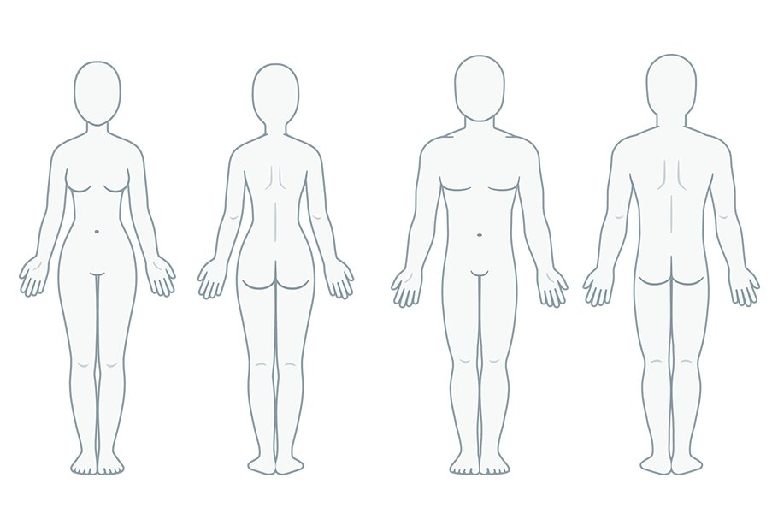
5. Have any other treatments/diets/exercise regimens helped these areas? ________________________________________________________________________________________________________________________________________________
6. What is your goal with Cryoskin? ________________________________________________________________________________________________________________________________________________
7. Do you have any questions about Cryoskin? ________________________________________________________________________________________________________________________________________________

