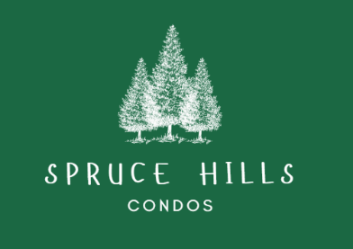
SPRUCE HILLS CONDOMINIUM ASSOCIATION
PO Box 414
Glen Gardner, NJ. 08826
Tel: 908-537-7515
Email: pmanager@sprucehills.org

Homeowners Association Meeting Agenda
June 24, 2026

1. Welcome and Call to Order
2. Treasurer’s Report
Account Balances-
**Note: Balances will change after tomorrow’s deposit and capital fund transfer.

 | April 2026 | June 2026
Checking – | $59,840.31 | $126,568.5
Savings - | $295,216.00 | $237,190.96
Capital Fund - | $183,836.73 | $204,252.06
Special Assessment- | $69,962.33 | $105,009.87

3. Items for Review and Approval
- Bills List
- April Meeting Minutes

4. Board Discussion
- Construction Updates
  - Bldgs 2,7,19 have punch list work; 1907 awaiting truss repair in crawl space (slated for 6/29-7/1).
- Rental Cap Implementation
- Need to rework and reword the amendment and submit for vote again
- Electronic Voting amendment
- Submit to community for vote to allow for electronic voting.
- Invoices & Payment Plans
- Buildings 2 and 7 have been billed.
- Owners who have not contacted the office to establish a payment plan are expected to pay by the due date.
- Landscape Vendor
- Yellowstone Landscape given 30 days to improve performance
5. General Updates
- Contractors on Premises
  - Residents must not approach or interfere with contractors while they are working.
  - Residents must NOT go to any of our Vendors place of business
- Owner/Tenant Forms
  - New forms will be distributed; it’s time to update them. Failure to return them will result in fines per the 2026 Fines & Fees Schedule.
- HOA Fee Increase
  - Reminder of the 2026 fee adjustment. We still have a small number of residents sending in the old Hoa amount. Please read our correspondence and send in the proper amount.
- New Online Payment System
  - The new system has launched, and correspondence has been sent out. If you did not receive an automated email or need assistant setting up. Please contact Terri and May In the office.
- No Feeding Wildlife or Stray Animals
  - Feeding wildlife is attracting rats and causing property issues.
- Pet Waste Cleanup
  - Multiple complaints continue. Owners must clean up after their pets; maintenance does not handle pet waste.
- Emergency Access to Units
  - A recent medical emergency required unit entry. Because a key was available in the lockbox, emergency responders gained access quickly and fatality was avoided. Without an emergency key on file, the office cannot assist with entry.
- Community Maintenance
- We are currently performing maintenance throughout the community.
- This includes updating signage, parking numbers and lines that have faded will also be repainted, amongst other things.
- Please comply with all correspondence from the office, as this is essential in allowing the maintenance team to complete their work efficiently and keep the community looking its best.

