Consider Donating  Open Cupboard Food Pantry:  Clothing, Food and Books  37 Old Highway 22, Clinton, NJ 08809  908/730-7320  Sustain Abilities:  Computers & Computer Accessories, Small Office Equipment, Small Kitchen & Household Appliances, Telephones and Cell Phones  264 Route 31 North, Washington, NJ 07882  908/689-1118  www.abilitiesnw.com  Warren County Habitat for Humanity Restore  Furniture and Household Items  384 Route 57, Washington, NJ 07882  908/835-1980 | 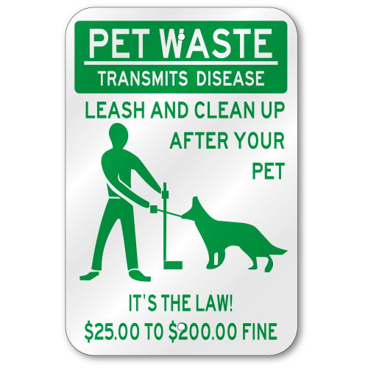  Entry Ways  NJ State Law prohibits any items to be stored in the entry ways as well as under the stairs | Spruce Hills  Condominium Association | # 01
IMPORTANT INFORMATION:  QUITE HOURS ARE 10:00 pm thru 7:00 am. Report noise or disturbing behavior to the State Police at 908/689-3100 | BOARD MEMBERS  PRESIDENT – Janet Traphagen  VICE PRESIDENT – Aaron Graf  TREASURER – William Palaferro  SECRETARY – Robert Hart  TRUSTEE – Joe De Vergillo  Fall/Winter 2019
 | P.O. Box 414  100 Spruce Hills Drive  Glen Gardner, NJ 08826 | Phone: 908/537-7515  www.sprucehills.org | Emergency Number:  800/879-7287  This is not an answering service and is for actual emergencies ONLY | Office Hours  Monday, Wednesday to Friday 7:00 am to 3:30 pm  Tuesday 2:00 pm to 6:00 pm

COMMUNITY ANNOUNCEMENTS  Christmas Tree Collections  Trees for disposal are to be dropped off behind the SHCA office prior to February 7, 2020. Do not dispose of them in the entryways, patios, decks, garbage areas or tree lines.  Snow Rules  - Move your vehicle to an open visitor parking area  - Do not park in the two yellow designated “no parking spaces” at the end of each building.  Please refer to the website for further instructions to avoid fines  2020 Pet Registration  All pets should be registered with the Borough of Glen Gardner and the SHCA office no later than January 31, 2020.  REMINDER: It is the responsibility of the pet owners to clean up and properly dispose of your pets’ waste.  rECYCLING RULES  - Pizza boxes are not recyclable and must be placed in the garbage dumpster  - All glass, aluminum and plastic containers must be rinsed prior to disposal  - All boxes must be broken down and secured with twine  - Plastic bags are not allowed in the recycling containers or receptacles and should be placed in the garbage dumpsters  A full listing of the Glen Gardner Recycling Program is available on the Spruce Hills website | Completed projects this year  - Clubhouse roof replaced  - Roof replacement on occupied buildings  - Removal of several dead or encroaching trees  - Rules and Regulations Handbook  - All water meters have been replaced  Property Management Office Closings:  November 28 & 29th  December 24th, 25 and 31st  January 1st, 2020  ASSOCIATION MEETINGS FOR 2020  January 21st February 18th March 17th  April 21st May 19th June 16th  July 21st August 18th September 15th  October 20th November 17th | AREA EVENTS  OCTOBER  Town of Clinton:  October 12th, EXPO and Main Street Marathon Packet Pickup October 13th, Main Street Half Marathon  October 18th, Haunted Village at the Red Mill  Glen Gardner:  October 31st Main Street Closed for Trick or Treat  November  Washington Borough:  November 2nd, BOO in the Boro 5k Race and Fun Run  Town of Clinton:  November 2nd, Annual Craft Beer Festival  November 29th – December 1st, Dickens Days  November 29th Community Tree Lighting  December  Town of Clinton:  December 6th, Annual Christmas Parade  Glen Gardner:  December 7th, Cookies and Cocoa with Santa

