Consider Donating  North Hunterdon Food Pantry  Food  200 Sanatorium Road, building 24, Glen Gardner  908/537-4824  Open Cupboard Food Pantry:  Clothing, Food and Books  37 Old Highway 22, Clinton  908/730-7320  Sustain Abilities:  Computers & Computer Accessories, Small Office Equipment, Small Kitchen & Household Appliances, Telephones and Cell Phones  264 Route 31 North, Washington  908/689-1118  www.abilitiesnw.com  Warren County Habitat for Humanity Restore  Furniture and Household Items  384 Route 57, Washington  908/835-1980 | 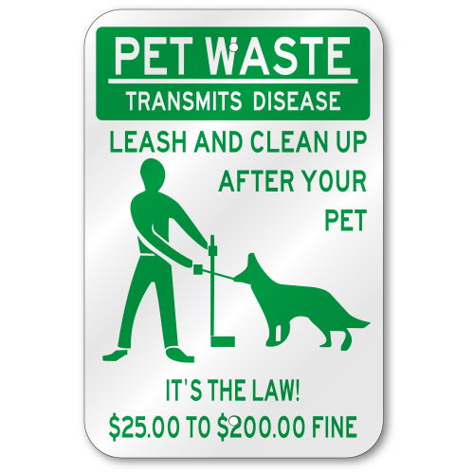  Entry Ways  NJ State Law prohibits any items to be stored in the entry ways as well as under the stairs.  Halloween  Included in this newsletter is a flyer that you can affix to your door if you want to welcome Trick or Treaters  Maintenance requests:  Are to be communicated to the property manager only. Not to the maintenance personnel or a Board Member. It is not their responsibility to communicate this with the Property Manager and your request maybe forgotten or overlooked for more significant requests. |   Spruce Hills  Condominium Association | # 05
IMPORTANT INFORMATION:  QUITE HOURS ARE 10:00 pm thru 7:00 am. Report noise or disturbing behavior to the State Police at 908/689-3100 | BOARD MEMBERS  PRESIDENT – Janet Traphagen  VICE PRESIDENT – Aaron Graf  TREASURER – Lindsay Licwinko  SECRETARY – Michelle Brito  TRUSTEE – William Palaferro  Fall / Winter 2021
 | P.O. Box 414  Glen Gardner, NJ 08826 |   Phone: 908/537-7515    www.sprucehills.org | Emergency Number:  800/879-7287  This is not an answering service and is for actual emergencies ONLY | Office Hours  Monday, Wednesday to Friday 7:00 am to 3:30 pm  Tuesday 2:00 pm to 6:00 pm
2021 COMPLETED PROJECTS  - Residing of the Clubhouse  - New Flooring and paint inside the Clubhouse  - Pool resurfacing  - Tree pruning & removal  - 9 decks replaced  CHRISTMAS TREES  All real Christmas trees are to be recycled and placed in the parking area across from the Post Office mailbox near the lower entrance, no later than February 1st, 2022  rECYCLING RULES  - Do not leave cans or bottles in plastic bags of any kind, empty bags into the containers. When possible, flatten milk, water & juice bottles to conserve space.  - Pizza boxes are not recyclable.  - Cardboard boxes must be broken down and flattened with all packing material removed and secured with twine.  - Newspapers, Magazines, Junk Mail and Office Paper must be tied in a bundle.  - AA, AAA, B, C, D & 9V Batteries go in the trash.  - Other metal or plastic items (toys etc.,) even if marked with a recycling symbol, are not to be placed in the recycling areas. Include them in the trash or check the Borough Recycling Program.  A full listing of the Glen Gardner Recycling Program is available on the Spruce Hills website  snow RULES  - Salt buckets will be placed in the entry of each building for resident use for icy areas on walk& driveways  - If you have more than two (2) cars, they must be either kept in a garage or in the office parking lot. Failure to do so will result in fines and towing  - All fleet and guest vehicles must be kept in the office parking lot. Failure to do so will result in fines and towing | Property Management Office Closings:  Friday, November 26th  Thursday, December 23rd & Friday, December 24th  Thursday, December 30th & Friday, December 31st  ASSOCIATION MEETINGS FOR 2022  January 18th February 15th March 15th  April 19th May 17th June 21st  July 19th August 16th September 20th  October 18th November 15th  Septic System  Please do not flush any of the following items  - Dental floss  - Wipes weather septic safe or not  - Cat litter  - Condoms  - Feminine hygiene products  - Diapers  - Cotton swabs  - Cigarette butts  - Coffee ground  - Any hazardous chemicals  Idling Cars  New Jersey has laws which prohibit the idling of a vehicle for more than 3 minutes. Call in complaints to the regional EPA office at 973/656-4444 | AREA EVENTS  Town of Clinton:  November 26th to 28th, Dickens’ Days  Glen Gardner:  November 13th, Holiday Craft Fair  December 18th @ 4:30pm, Santa on a firetruck  Tbd, Cookies and Cocoa with Santa  Hampton:  November 6th to 8th & December 7th to 9th, Playhouse Christmas  Easton:  November 6th & 7th, Bacon Festival  Hackettstown:  November 14, Free Holiday Dance Class  Newark:  November 3rd to 7th, Disney on Ice  PET REGISTRATION  All Residents are required to abide by the ordinances of the Borough of Glen Gardner, the laws of the State  of New Jersey and the rules herein. The term “Pets” used herein refers to all cats and dogs.  Unit Owners are required to register all pets with the Borough of Glen Gardner upon move-in and then in January of each year.  A copy of this registration along with a photo of their pet/pets must be delivered to the Property Manager no later than January 31st of every year.

