Consider Donating  North Hunterdon Food Pantry  Food  200 Sanatorium Road, building 24, Glen Gardner, NJ  908/537-4824  Open Cupboard Food Pantry:  Clothing, Food and Books  37 Old Highway 22, Clinton, NJ 08809  908/730-7320  Sustain Abilities:  Computers & Computer Accessories, Small Office Equipment, Small Kitchen & Household Appliances, Telephones and Cell Phones  264 Route 31 North, Washington, NJ 07882  908/689-1118  www.abilitiesnw.com  Warren County Habitat for Humanity Restore  Furniture and Household Items  384 Route 57, Washington, NJ 07882  908/835-1980  IMPORTANT INFORMATION:  QUITE HOURS ARE 10:00 pm thru 7:00 am. Report noise or disturbing behavior to the State Police at 908/689-3100 |  | Entry Ways  NJ State Law prohibits any items to be stored in the entry ways as well as under the stairs  Septic System  Please do not flush any of the following items  - Dental floss  - Wipes weather septic safe or not  - Cat litter  - Condoms  - Feminine hygiene products  - Diapers  - Cotton swabs  - Cigarette butts  - Coffee grounds  - Any hazardous chemicals |  | Spruce Hills  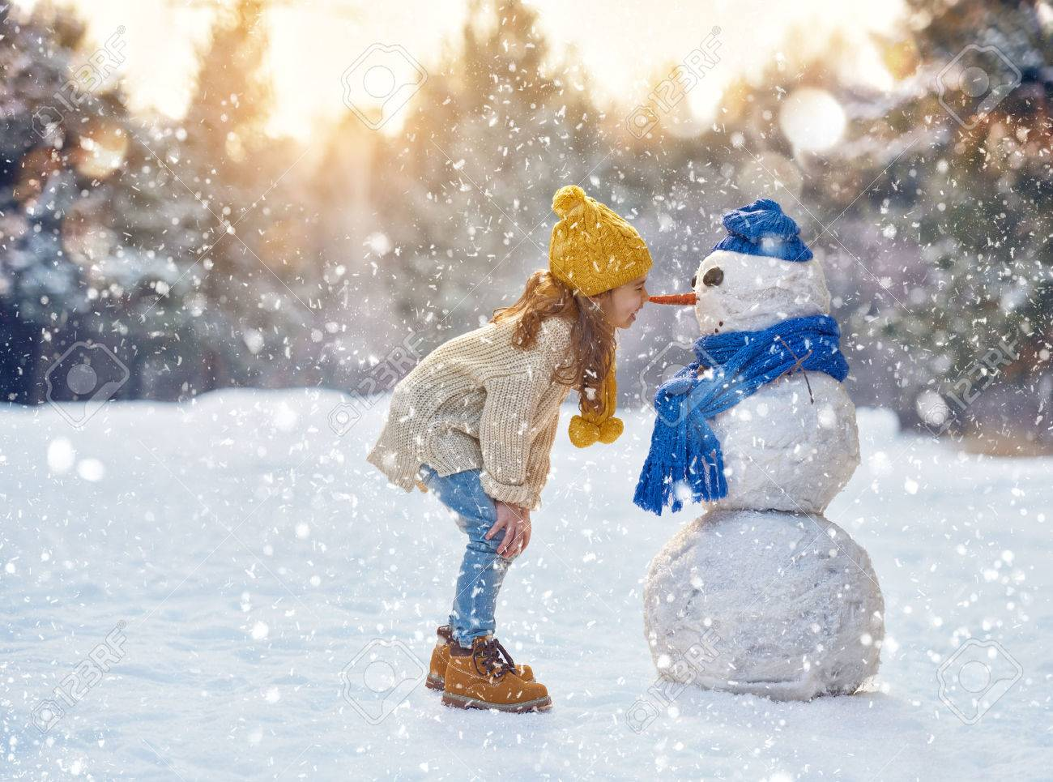  Condominium Association  BOARD MEMBERS  PRESIDENT – Janet Traphagen  VICE PRESIDENT – Aaron Graf  TREASURER – William Palaferro  SECRETARY – Michelle Brito  TRUSTEE – Robert Hart  Fall/Winter 2020 |  |  |  | # 03
 | P.O. Box 414  Glen Gardner, NJ 08826 |  | Phone: 908/537-7515  www.sprucehills.org |  | Emergency Number:  800/879-7287  This is not an answering service and is for actual emergencies ONLY | Office Hours  Monday, Wednesday to Friday 7:00 am to 3:30 pm  Tuesday 2:00 pm to 6:00 pm
COMMUNITY ANNOUNCEMENTS  Christmas Tree Collections  Trees for disposal are to be dropped off behind the SHCA office prior to February 5, 2021. Do not dispose of them in the entryways, patios, decks, garbage areas or tree lines.  Snow Rules  - Move your vehicle to an open visitor parking area  - Do not park in the two-yellow designated “no parking spaces” at the end of each building.  - Salt buckets will be placed in the entry of each building for resident use for icy areas on the walks or driveway  Please refer to the website for further instructions to avoid fines  2021 Pet Registration  All pets should be registered with the Borough of Glen Gardner and the SHCA office no later than January 31, 2021.  REMINDER: It is the responsibility of the pet owners to clean up and properly dispose of your pets’ waste.  rECYCLING RULES  - Pizza boxes are not recyclable and must be placed in the garbage dumpster  - All glass, aluminum and plastic containers must be rinsed prior to disposal  - All boxes must be broken down and secured with twine  - Plastic bags are not allowed in the recycling containers or receptacles and should be placed in the garbage dumpsters  - Bulk items stickers must be obtained for all non-household waste items  - $3.00 each from the HOA  - $2.00 each from Glen Gardner Borough  A full listing of the Glen Gardner Recycling Program is available on the Spruce Hills website | Patio Doors  - If you are replacing a sliding glass door, you must call the office for an inspection by the maintenance team  Completed projects this year  - Clubhouse windows and siding replaced  - Removal of several dead or encroaching trees  - Deck supports & flashing  Property Management Office Closings:  November 26th & 27th  December 24th, 25 and 31st  January 1st, 2021  ASSOCIATION MEETINGS FOR 2021  January 19th February 16th March 16th  April 20th May 18th June 15th  July 20th August 17th September 21st  October 19th November 16th  A special thank you to Joe DeVergillio, we would like to thank you for all your years of service and support to the Association by volunteering your time as a Board member.  We would also like to thank Michelle Brito for filling the vacant spot left be Joe when he had to resign from the Board due to family commitments | LEASING OF UNITS  The Following forms are required (prior to lease start date)  - A minimum of a 1-year lease is required  - Information sheets for both the owner and the tenant  - Lease Rider  - Rules & Regulations requirements  iNSTALLING A SATALITE DISH  - You must call the office prior to installation  Modifications of units  - Unit modifications must be preapproved by the Board of Trustees  AREA EVENTS  OCTOBER  Town of Clinton:  Pumpkin Fest, Hunterdon Art Museum  Glen Gardner:  October 31st Main Street Closed for Trick or Treat  NOVEMBER  Town of Clinton:  November 27th – November 29th, Dickens Days  November 27th, Winter Village at the Red Mill  DECEMBER  Glen Gardner:  December 5th, Cookies and Cocoa with Santa  December 12th, Holiday Bake Sale

