Consider Donating  North Hunterdon Food Pantry  Food  200 Sanatorium Road, building 24, Glen Gardner, NJ  908/537-4824  Open Cupboard Food Pantry:  Clothing, Food and Books  37 Old Highway 22, Clinton, NJ 08809  908/730-7320  Sustain Abilities:  Computers & Computer Accessories, Small Office Equipment, Small Kitchen & Household Appliances, Telephones and Cell Phones  264 Route 31 North, Washington, NJ 07882  908/689-1118  www.abilitiesnw.com  Warren County Habitat for Humanity Restore  Furniture and Household Items  384 Route 57, Washington, NJ 07882  908/835-1980 | 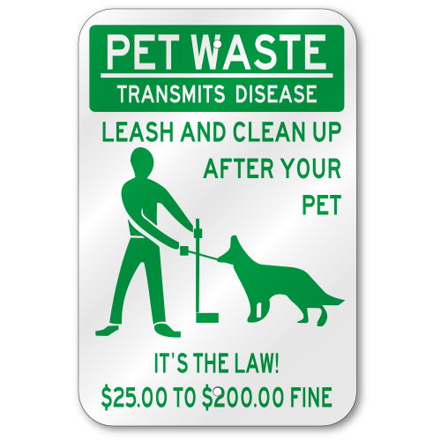  Elections  Ballots are due May 19th  Electronic Recycling  Borough of Glen Gardner will hold an electronic recycling on Saturday, April 18th  Entry Ways  NJ State Law prohibits any items to be stored in the entry ways as well as under the stairs |   Spruce Hills  Condominium Association | # 02
IMPORTANT INFORMATION:  QUITE HOURS ARE 10:00 pm thru 7:00 am. Report noise or disturbing behavior to the State Police at 908/689-3100 | BOARD MEMBERS  PRESIDENT – Janet Traphagen  VICE PRESIDENT – Aaron Graf  TREASURER – William Palaferro  SECRETARY – Robert Hart  TRUSTEE – Joe De Vergillo  Spring – Summer 2020
 | P.O. Box 414  100 Spruce Hills Drive  Glen Gardner, NJ 08826 |   Phone: 908/537-7515    www.sprucehills.org | Emergency Number:  800/879-7287  This is not an answering service and is for actual emergencies ONLY | Office Hours  Monday, Wednesday to Friday 7:00 am to 3:30 pm  Tuesday 2:00 pm to 6:00 pm
COMMUNITY ANNOUNCEMENTS  THE POOL  The pool will be open on May 23rd thru June 22nd  Weekends only 10:00 am – 7:00 pm  The pool will be open daily starting on June 23rd thru September 7th  Monday thru Friday 12:00 pm – 7:00 pm.  Saturday & Sunday 10:00 am – 7:00 pm.  The pool will return to weekends only, if the local high schools are in session. Lifeguards will not be provided for any weekday of the week that high school is in session  Grills  Smokers, propane and charcoal grills are STRICTLY Prohibited, per the State of New Jersey  rECYCLING RULES  - Pizza boxes are not recyclable and must be placed in the garbage dumpster  - All glass, aluminum and plastic containers must be rinsed prior to disposal  - All boxes must be broken down and secured with twine  - Plastic bags are not allowed in the recycling containers or receptacles and should be placed in the garbage dumpsters  A full listing of the Glen Gardner Recycling Program is available on the Spruce Hills website | Dryer vent inspections  Invoice or certificate is due to the office, no later than September 30th  Property Management Office Closings:  Friday, April 10th  Monday, May 25th  Friday, July 3rd  Monday, September 7th  ASSOCIATION MEETINGS FOR 2020  January 21st February 18th March 17th  April 21st May 19th June 16th  July 21st August 18th September 15th  October 20th November 17th  Pet Sitting  A resident pet owner will be allowed to pet sit. The pet must be registered & photographed in the office with the arrival and departure dates of the pet. No resident can “pet sit” more than 14 days in a fiscal year. A nominal fee of $ 5.00 per day will be assessed.  Pet Park  You may purchase a key to the dog park for $ 10.00 per year.  According to our rules and regulations and the Borough of Glen Gardner, it is the Pet Owners’ responsibility to clean up after and dispose of waste properly anywhere on the property! | AREA EVENTS  Asbury:  May 3rd, Run for the River  Belvidere:  September 11th-13th, Victorian days  Town of Clinton:  April 5th, Bridal show, open house  April 18th, Bring the Heat Chili Cook-off  May 2nd, The Red Mill Derby  May 17th, Wheels for the Wheel car show  June 12th, Flag Day parade  July 17th-18th, sidewalk sales  August 2nd, Kids’ day  Glen Gardner:  June 14th, Cars in the park  July 4th, Fire truck rides  Flemington:  April 18th, Vamos Health Fair  September 19th; Flea market and Sidewalk sale  Hackettstown:  May 1st-3rd; Spring Festival  Washington Borough:  May 9th: Warren County Art, Craft & Music Festival

