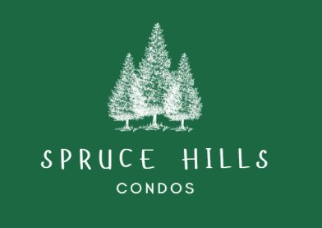
SPRUCE HILLS CONDOMINIUM ASSOCIATION
PO Box 414
Glen Gardner, NJ. 08826
Tel: 908-537-7515
Email: pmanager@sprucehills.org

HOA Open Meeting Minutes December 3, 2025

In Attendance:
Property Administrator: Terri Slagle 1515
Property Assitant: May Mastapeter
Board Members:
- President: Lucia Mastapeter 1109
- Vice President: John Brown 1701
- Treasurer: Jason Yard 1304
- Secretary: Gina Ambrosio 2014- (Zoom)
- Trustee: Carrie Spilatro 1608- (Zoom)

Unit Owners

In Person | Unit | Zoom
M. Abdaliah  Tannya Abdallah  Jim Trudel | 1802  1802  509 | Jeff Stieh 614  Jess Patane 1801  Carrie Spilatro 1608/410  Gina Ambrosio 2014  Marilyn 212  Rebecca 503  Jen 1104  William Palaferro Unit 815  Matt D 503  Lynn 1912  Karen 603  Maryann Zahorchak 1713  Joe D 406  Laura 1416  Rosennies 1804  Michael Ladolcetta 1211/1213  Samantha R. 1516  Vassili 105  Justin’s iPhone 607

Welcome and Call Meeting to Order at 7:05pm

- Bills list approved
- October minutes approved
- Approval of 2026 Fines and Fees

Status of Septic System
- They blew out lines and cleaning beds in the leach fields. They hadn’t been done in 40 years. There was 40 years of sludge. There has been a noticeable improvement in the catch basket since pipe replacement and hand delivered letters to all residents.

Water Main Break
- Cedar Ridge fixed. The approximate cost was 13,000. Water and gas lines were nearby, unable to dig; Had to bring a vacuum hose, we lost 50K gallons of water. We will be inquiring with the borough for a credit.

Audit Status
- Ongoing. QuickBooks was not reconciled going back to 2 prev. property managers. The accounting firm is making progress but it’s tedious. Will still seek loan to complete construction in the remaining buildings.

Loan Status
- Pending completion of audit.

HOA fees
- Will be increased January 2026 to $315 monthly

Construction
- Going as planned. KP12 is resuming construction on 12/2 with building 2 then building 7 to follow (permits were previously obtained). We are hoping to get the loan to complete construction faster. This will help keep down building costs and get us out of unwarrantable status. We won’t know loan details, term and interest until audit is completed.

General Updates
- Reminder Pictures with Santa 12/07 cost $10.
- Pardini responded to attorney letter; hopefully resolution for units 503/504 and 413/414
- There will be new unit owner forms sent out to all in 2026
- Implementing a new pay system
- The issue of speeding was brought up in open discussion as well.
- Resolution to Cap Rentals- meeting with attorney, waiting for attorney to schedule. Mentioned again it will require a community wide vote with 2/3 in favor.

