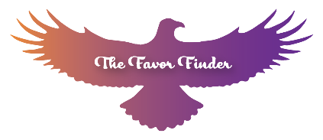
I acknowledge that Jamee Shermer is a Heart Healing Practitioner and not a professional counselor. To the best of her ability, she helps facilitate connection to God and inner renewal. I understand that specific results are not guaranteed, and progress may be immediate or take place over a period of time. I understand Jamee and anyone on her prayer team is committed to confidentiality of any information that is disclosed during the prayer session with the following exception:
I accept and acknowledge that Jamee Shermer is required by law to report any intent of a person to take harmful, dangerous or criminal action against another person or against themselves and that they are also required to report any current act of child or elderly abuse or neglect.
Release of Liability states that I have voluntarily sought assistance and that I am under no obligation to accept or reject any of the advice or help I might receive from Jamee Shermer. I agree to hold harmless Jamee Shermer or any prayer team member from any and all liability, loss or damage of any kind that may arise as a result of the ministry I receive from her or her team.
I state that I have voluntarily sought assistance and that I am under no obligation to accept or reject any of the advice or help I might receive from Jamee Shermer and her prayer team.
Your session may be recorded and sent to you if you chose. All uploaded recordings are sent to Jamee Shermer’s private channel on Youtube and only you have access to the private recording.
The 75$ is non-refundable if you don’t show up for your session within the first 15 minutes.
If you schedule a pack of 3 sessions it will be $60 per session for a total $180.
Signature:

Date:

