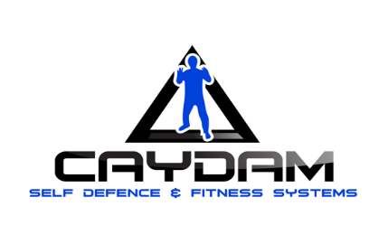
MEMBERSHIP APPLICATION FORM

NAME:

DATE OF BIRTH:

ADDRESS:
POSTCODE:

Name of parent(s)/guardian(s) - if Under 18

____________________________________MOBILE No: __________________________

____________________________________MOBILE No: __________________________

Parent’s email if under 18 years : ______________________________________________

Student’s email (if applicable)___________________________________________________

PLEASE LIST ANY MEDICAL CONDITIONS (E.G: ASTHMA, DIABETES, EPILEPSY):

RELEASE & INDEMNITY
I hearby authorise Caydam Karate to act on my behalf should my child require medical attention, and release Caydam Karate from any liability for injury incurred by my child at Caydam Karate programmes.

_x________________________ _____/_____/_____
APPLICANT SIGNATURE Date
(Legal Guardian/Parent if Under 18)

From time to time, audio and/or visual materials are recorded during training classes, programs & events for future promotional and training purposes. Please tick the box if you do not wish your child/ren to participate in such activities.

