Washington Chamber of Commerce

Community Partnership & Sponsorship Form

Business Information
Business Name: ________________________________________________________________
Contact Person: __________________________________________
Phone: ____________________________ Email: ____________________________
Address: _______________________________________________________________________

Sponsorship Levels (Select One)
Chamber Events Include:
Team Up to Clean Up • Chamber Membership Meetings (All Year) • Fair Parade • Fall Decorating Contest • Mardi Gras Decorating Contest • Christmas Festival Movie Night • Holiday Punch Card Program

☐ Premier Community Partner – $3,000
• Newsletter acknowledgement on every issue
• Logo + link on Chamber website homepage
• Special recognition & signage at ALL Chamber Events
• Featured social media post per event
• Recognition plaque
☐ Community Champion – $2,000
• Sponsorship of 3 events of choice
• Logo on marketing
• Event signage
• Recognition at Chamber meetings
• Social media features
Events: __________________________________ | __________________________________ | __________________________________
☐ Event Partner – $1,000
• Sponsorship of 2 events of choice
• Logo on marketing
• Event signage
• Social media recognition
Events: __________________________________ | __________________________________
☐ Supporting Sponsor – $500
• Sponsorship of 1 event
• Name/logo on flyer
• Event signage
• Social media thank you
Event: __________________________________
☐ Community Friend – $250
• Name listed on event materials
• Social media recognition

Payment Information
Amount Enclosed: $__________________ Method: ☐ Check ☐ Cash ☐ Other _____________
Make checks payable to:
Washington Chamber of Commerce
Mail to:
211 11th Ave. • Franklinton, LA 70438

Contact Information
📞 985-922-3357 | ✉ washingtonchamberofcommerce@gmail.com | 🌐 www.washingtonchamberofcommerce.com

QR Code 1:
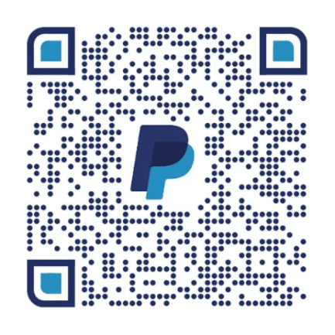
QR Code 2:
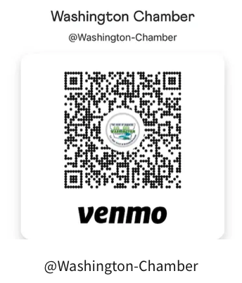

Authorized Signature: _________________________________ Date: ___________________

Thank you for supporting the Washington Chamber of Commerce and investing in our community!

