Ozone disinfection Comparison of disinfectants
Comparison between ozone and other disinfectants
Ozone is a very powerful disinfectant. Table 1 compares Ct-values (concentration * time) of various disinfectants for the deactivation of viruses.
Although chlorine is very suitable for the deactivation of bacteria and viruses, it cannot be used to deactivate protozoa.
Table 2 shows the disinfection rate for the Giardia cyst. In this table, you can see that chlorine and chloramines have lower Ct-values. This means that ozone is a more powerful disinfectant to deactivate this microorganism.
The protozoa Cryptosporidium is hardly deactivated by chlorine and chloramines [30,31]. The Ct-value for deactivation by chlorine varies between 3000 and 4000 mg min/L for 1-log deactivation (= 90% deactivation). Both tables are derived from the Environmental Protection Agency (EPA) [30].
Table 1: Ct-values for the deactivation of viruses by various disinfectants
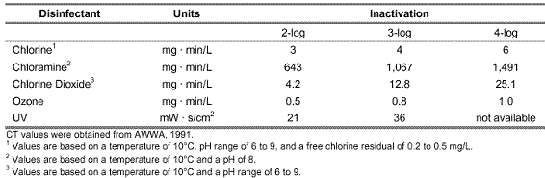
Table 2: Ct-values for the deactivation of Giardia cysts by various disinfectants
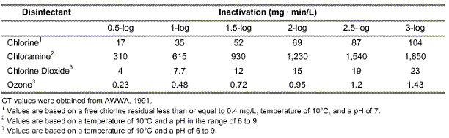
The benefit of ozone is that it influences pH and temperature minimally on a broad spectrum. Although ozone solubility decreases when temperatures rise, disinfection rates increase per 10°C (factor 2 or 3). Within the range of 0 – 30°C, these two factors diminish one another [6]. The disinfection rate of ozone hardly changes in a pH range of 6 – 8,5 [19]. For certain resistant microorganisms (such as Giardia Muris), the disinfection rate increases at higher pH values [30,34]. For other species of microorganisms, this is the other way around.
Other benefits of ozone application are:
- No remaining tastes or odors after treatment
- Disinfection byproduct formation is minimal (mainly when bromine is absent)
- Ozone can remove disinfection byproduct precursors (substances that introduce disinfection byproduct formation)

