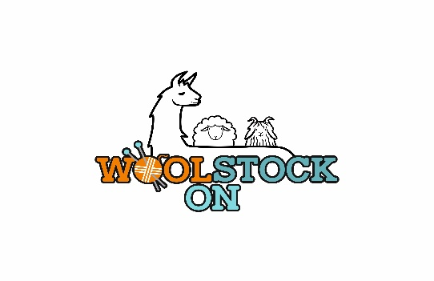**WoolstockON 2023 – Vendor Registration**

**Saturday, October 14, 2023**

Paris Fairgrounds – 139 Silver St., Paris, ON N3L 1V5

**Vendor Registration Instructions:**

Please fill in all fields of the form and email back to [fleecefestival@gmail.com](mailto:fleecefestival@gmail.com) No Payment is required at this time as you are being placed on our waiting list.

Exhibitor Name: _________________________________________

Contact Name: _________________________________________

Address:___________________________________ City:___________________

Province:____________ Postal Code: ____________ Phone: _________________

Email: ______________________________ Website:_______________________

**Description of products and services offered at your booth: (pictures to be emailed)

**Indicate booth preference:**

**10 x 10 booth in heated space _______**

**10x 10 booth in unheated space ________**

**10 x 20 booth in heated space _______**

**10 x 20 booth in unheated space _______**

**Also you will need to attach a few pictures of your products.**