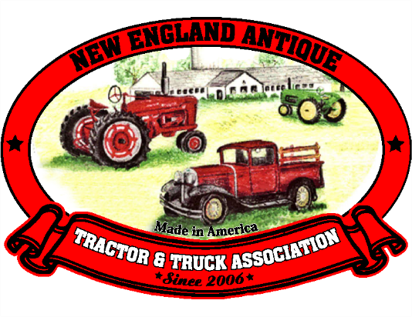

27 Francis Farm Road, Rehoboth, MA 02769

The New England Antique Tractor & Truck Association is excited to be holding its first members meeting for 2019 on Sunday, February 10, at 1 pm at the Acushnet Grange Hall, 1121 Main Street in Acushnet, MA 02743. Membership dues will be decided upon at this meeting.

We are a 501(c) 3 non-profit first established in Rehoboth, MA in 2006. We are welcoming new members to our group. You do not have to have a restored tractor or even a running tractor to be a member. We take part in antique tractor and truck shows in New England as well as local parades, Fairs and farm related events. We love showing off our antique garden and farm tractors, be they restored or still in their “work clothes”! Come join us on Feb 10th and meet some great people!

If you have any questions, call or email, Bev Baker 508-222-7109 or bgbake@comcast.net

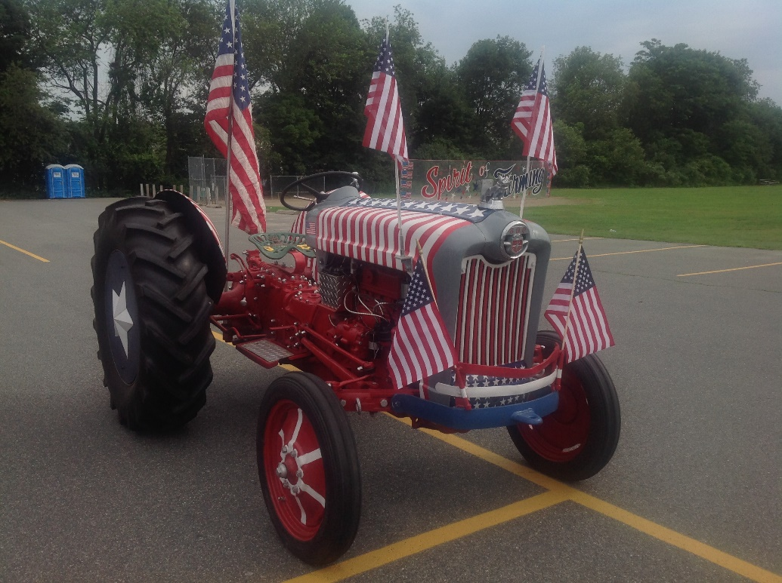

A 1956 Ford 800 owned by Tony Vacca of Franklin, MA.