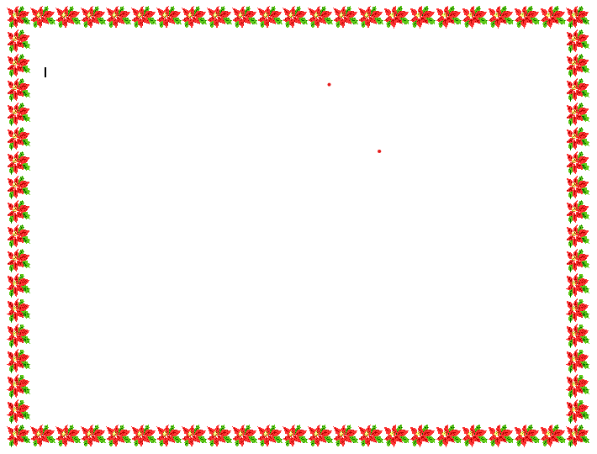
2025 Christmas Message

Fr. Raymond Lafontaine

Pastor, St. Veronica’s Parish
The Holy Moment That Changed the World
Dear Brothers and Sisters in Christ,
At Christmas we celebrate the most extraordinary Holy Moment in human history. In the quiet of Bethlehem, God chose to enter our world not with power or spectacle, but as a child, born in humility and placed in a manger. Heaven touched earth in a moment so simple it could easily have been missed.
In Holy Moments, Matthew Kelly reminds us that a Holy Moment is a moment when we open ourselves to God, set aside self-interest, and choose what love asks of us. The Christmas story is filled with such moments. Mary’s courageous “yes,” Joseph’s faithful obedience, the shepherds leaving their fields, and the Magi following the star—all are ordinary people responding to God with trust. Through their small, faithful choices, the world was forever changed.
The birth of Jesus reveals something essential about God and about us. God works through the ordinary moments of human life. He enters our homes, our struggles, our relationships, and our daily routines. Christmas assures us that holiness is not reserved for the extraordinary; it is discovered in the everyday choices to love, forgive, serve, and hope.
This is the invitation of Christmas: not only to remember Christ’s birth, but to allow Him to be born again in us. Each time we choose kindness over indifference, patience over anger, generosity over comfort, we create a Holy Moment where God’s love becomes visible in the world.
As we celebrate Christmas, may our hearts be open to the quiet ways God is present among us. May our homes be places of peace, and may our lives be filled with Holy Moments through which Emmanuel—God with us—continues to dwell in our world.
Wishing you a blessed and joyful Christmas,
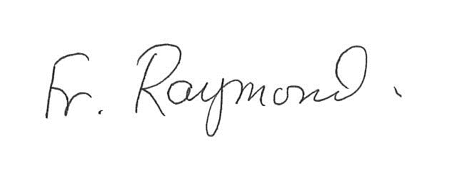
Fr. Raymond Lafontaine, Pastor

