MASS SCHEDULE

WEEK OF SEPTEMBER 7TH, 2025

SATURDAY, SEPTEMBER 6TH, 2025
4:30 P.M. T.A.McConnell The Family

SUNDAY, SEPT. 7th, 2025 – 23rd SUNDAY IN ORDINARY TIME
10 :30 A.M. All Parishioners

MONDAY, SEPT. 8th, 2025-NATIVITY OF BLESSED VIRGIN MARY

TUESDAY, SEPTEMBER 9th, 2025
7:00 P.M. Suzanne Kostaniuk The Family

WEDNESDAY, SEPTEMBER 10th, 2025
9:15 A.M. Jacques Halsy Russaouën The MacDonald-Baudru Family

THURSDAY, SEPTEMBER 11TH, 2025
9:00 A.M. Sadie Ryan Gwen Wilmut

FRIDAY, SEPTEMBER 12TH, 2025
9:00 A.M. Francisca Williams The Family

SATURDAY, SEPTEMBER 13TH, 2025
4:30 P.M. Cecile Manning Shaun Murphy

SUNDAY, SEPT. 14th , 2025 – EXALTATION OF THE HOLY CROSS
9 :00A.M. Leona Lacoste Louise Tarte Begin
11 :00 A.M. Memorial Society
_________________

Gift for Fr. Fred
With great thanks, we can report that as of August 17th we had raised $11,000.00 for a well to be dug in Kenya as a tribute to Father Fred’s commitment to our parish for the past 22 years. Because many parishioners continue to express an interest to contribute, we have decided to see if we can raise an additional amount to finance a second well. We have extended the giving deadline to Sunday September 14th. To receive a tax receipt, use the special envelopes in the church pews, but you must include your weekly envelope number for 2025. Clean water will certainly bring great joy to an African village but also very heart warming for Fr. Fred. We will keep you posted

Gospel reflection for 23rd Sunday in Ordinary Time
The strong contrast in Jesus’ words (hate father and mother) is Hebrew idiom for what we would call establishing priorities. We may have to make choices between the call of the Lord and the pull of family. Jesus is talking to the large crowds who were drawn to him; here as elsewhere he warns against an attraction that is too impulsive and emotional. What do you ask of me, Lord? Let me know the cost.

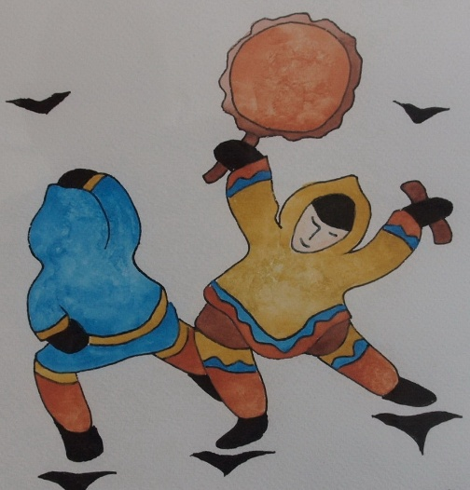
Listening To Indigenous Voices
Take this opportunity to learn about our indigenous brothers and sisters. This 13 session program is animated by Deacon Gerry Turpin who worked with the Inuit for 16 years. The program will be offered at St. Veronica Parish beginning in October. For information and to register please contact Deacon Gerry at 514-631-1616 or at turpin@cooptel.qc.

The St. Veronica's Seniors Club luncheon will be held at the Sarto Desnoyers Community Center on Friday, September 12/25. Doors open at 12:00 noon. The meal is sandwiches from Scores and desert. The cost is $20.00, the PHP donation diapers for the Dorval Mosque and the speaker is Dr. Christopher Labos. Please reserve before 12:00 noon on Monday, September 8th. New members are most welcome. Please call Henny Rabôt at 524 631 4003 if you need more info.

CHILDRENS’ FAITH EDUCATION REGISTRATION AND BOOK PICK UP: There will be registration and book pick-up on Saturday, September 20th at 10:30 a.m. or Saturday, September 27th at 10:30 a.m. in the parish. You are only required to attend one of the meetings. We will also be accepting new registrations at these meetings. We welcome children from 3 years of age and older in our Pre-K/K class. Children must complete Level One and Two before receiving First Reconciliation and First Communion and they must complete the remaining Faith Education levels before receiving the Sacrament of Confirmation in Level Six. Classes will begin on the weekend of October 25/26. Please pass this information to others who may be interested in having their children join the program. If you require more information please email Beverley Wiltsie at DirectorReligiousEducation@videotron.ca or telephone her at the parish office.
ALTAR SERVERS :We are looking for altar servers for Saturday and Sunday masses starting ASAP.If your child has received His/Her 1st Communion and would be interested in helping out…please contact Ron Cooney @ 514 636-6565, or email roncooney70@aol.com
A CWL Book Sale will be held the weekend of October 18/19th. Book donations (NO magazines or school books please) will be welcomed until October 14th. Thank you for your continued support. For more information, please call Huguette at 413-428-9835.
2025 DONATION ENVELOPES: Parishioners using envelope numbers 308, 309, and 343. Can you please call the office as soon as possible 514 631-6381. As well, counters have requested that you please put amounts on your envelopes. Thank you

