MASS SCHEDULE

WEEK OF OCTOBER 12TH, 2025

SATURDAY, OCTOBER 11th, 2025
4:30 P.M. Nester Minerva Nelly & Melva Cotiangco

SUNDAY, OCT. 12th, 2025 – 28TH SUNDAY IN ORDINARY TIME
9 :00A.M. All Parishioners
11 :00 A.M. Leona Lacoste Deacon Gerry

MONDAY, OCTOBER 13TH, 2025

TUESDAY, OCTOBER 14TH, 2025
7:00 P.M. Fr. John Walsh Stephen & Erlinda

WEDNESDAY, OCTOBER 15th, 2025-ST.TERESA OF JESUS
9:15 A.M. Carol Caranci Friends

THURSDAY, OCTOBER 16th, 2025 –ST. MARGUERITE D’YOUVILLE
9:00 A.M. All Parishioners

FRIDAY, OCTOBER 17th, 2025-ST.IGNATIUS OF ANTIOCH
9:00 A.M. Suzanne Picard Joanne Legault

SATURDAY, OCTOBER 18th, 2025
4:30 P.M. Teresa Dolce Stefani & Rocco

SUNDAY, OCT. 19th, 2025 – 29TH SUNDAY IN ORDINARY TIME
9 :00A.M. Maureen & Alex Gomes The Burtles Family
11 :00 A.M. Michael Scott The McDonaugh Family
_________________

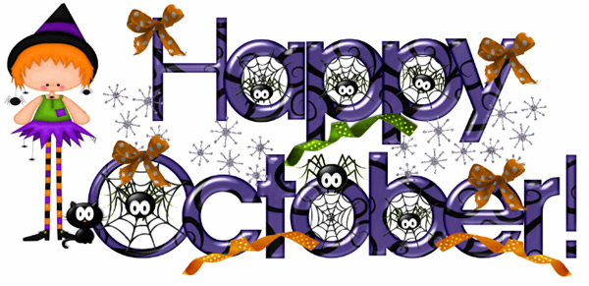

Meet the new pastor, Fr. Raymond Lafontaine, E.V.
When I first entered your (our!) beautiful church for the Homecoming Mass and Farewell to Fr. Fred in September, I was inspired by the banner: “There are no strangers at St. Veronica’s, only friends you have not yet met!” I look forward to meeting and us getting to know each other better in the months ahead.
Allow me to introduce myself. I grew up in Montreal’s north end (St. Rita’s, Ahuntsic), the ninth of ten children in a musical family. After studying science and working as an actuary, I entered seminary in 1986, alongside Fr. Fred and Fr. Tom. I was ordained in 1991, and after serving as an associate pastor in DDO, I pursued graduate studies in moral theology in Rome, earning my doctorate in 2001.
Returning to Canada, I served in vocation ministry, was a Catholic chaplain at Concordia, and taught moral theology at the Grand Séminaire. I also spent 12 years as pastor at St. Monica’s in NDG, engaged in faith formation, spiritual accompaniment, and ecumenical dialogue. From 2001 to 2017, I taught at Concordia University in courses from Catholicism and ethics to bioethics and theology in film.
In 2016, Archbishop Lepine appointed me as episcopal vicar for the English-speaking community and director of the Office for English Pastoral Services. During my recent sabbatical, I focused on synodality, which led to my role as a facilitator at the 2024 Synod of Bishops on becoming a synodal, missionary church.
I am excited to serve as your pastor at St. Veronica’s, working with our team to build a parish rooted in warm community, active participation, and sharing in the Church’s mission to live and proclaim the Gospel.
You’ll get to know me through my preaching and involvement, and I look forward to sharing my love of music, cinema, and pop culture. I’m a fan of *The Chosen*, believe Jesus invites us into deep relationships, and am eager to walk together with you—embracing our mission to bring the Gospel to Dorval. No matter the noise of planes overhead, we will lift Jesus higher and witness to our faith as a community.


Please encourage parishioners to visit our Parish Website www.saintveronicasdorval.ca .
You may also access the Parish website by scanning the QR code, on the left, with the camera on your smart phone or ipad.

CATECHIST MEETING: There will be a start-up Catechist meeting on Saturday, October 18th at 10:30 a.m. in the parish hall for all Catechists and Assistant Catechists. We will review the up-coming year, hand out the catechist manuals and enjoy some time to welcome our new pastor!

CHILDRENS’ FAITH EDUCATION: Classes will begin on the weekend of October 25/26. We welcome children from 3 years of age and older. Children must complete Level One and Two before receiving First Reconciliation and First Communion and they must complete the remaining Faith Education levels before receiving the Sacrament of Confirmation in Level Six. Please pass this information to others who may be interested in having their children join the program. If you require more information please email Beverley Wiltsie at DirectorReligiousEducation@videotron.ca or telephone her at the parish office.

