MASS SCHEDULE

WEEK OF SEPTEMBER 14TH , 2025

SATURDAY, SEPTEMBER 13TH, 2025
4:30 P.M. Cecile Manning Shawn Murphy

SUNDAY, SEPT. 14th, 2025 – EXALTATION OF THE HOLY CROSS
9 :00A.M. Leona Lacoste Louise Tarte Begin
11 :00 A.M. Memorial Society
John Albert Bishop Marilou
Tamayo/Gabarda Family Marilou
Suzanne Kostaniuk The Family
Florentino Rosario Pat & Family
Marie Marguerite Godin Gail & Robin
Jean & Elsie Gauthier The Family
Doris & Ernest Maenz Andrea & Andrew
Kevin Maenz Andrea & Andrew
Rudyard Spence Andrea & Andrew
Mr. & Mrs. Marcos Banawa The Garcia Family
Fernando Garcia The Garcia Family
Ron & Vicky Mersereau Diane
Christian Daigneault The Raso Family
John O`Donnell Sylvie Rogers
Maureen Brochu Sylvie Rogers
Claire L’Àfricain Gwen Wilmut
Richard Loj Wife & Children
Luis Aguilar Aura Barton
John Kelly Josie & Alex

MONDAY, SEPTEMBER 15th, 2025-OUR LADY OF SORROWS

TUESDAY, SEPTEMBER 16th, 2025-ST.CORNELIUS & ST. CYPRIAN
7:00 P.M. Alfredo G. DeLa Cruz Stephen & Erlinda

WEDNESDAY, SEPTEMBER 17th, 2025
9:15 A.M. Claire L’Africain John & Judy Turner

THURSDAY, SEPTEMBER 18TH, 2025
9:00 A.M. Richard Loj Dorotea Aquino

FRIDAY, SEPTEMBER 19TH, 2025
9:00 A.M. Suzanne Picard Joanne Legault

SATURDAY, SEPTEMBER 20TH, 2025
4:30 P.M. Paul Amyot Gregorio & Anita

SUNDAY, SEPT. 21st, 2025 – 25TH SUNDAY IN ORDINARY TIME
9 :00A.M. Gwen & Percy Burtles The Burtles Family
11 :00 A.M. All Parishioners
_________________

Gospel reflection for the Exaltation of the Cross
It is so common for people to associate self-examination and guilt with religion but here we are drawn to the core: God loves us and calls us to life. The cross is full of contradictions as we speak of it in terms of life, freedom and hope. I ask God to allow the contradictory message of the Gospel to have sway in my life.

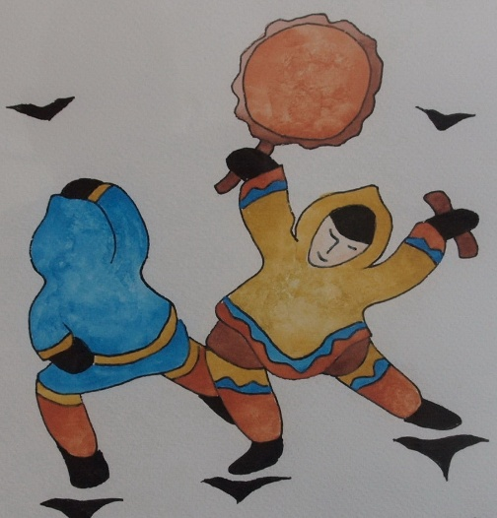
Listening To Indigenous Voices
Take this opportunity to learn about our indigenous brothers and sisters. This 13 session program is animated by Deacon Gerry Turpin who worked with the Inuit for 16 years. The program will be offered at St. Veronica Parish beginning in October. For information and to register please contact Deacon Gerry at 514-631-1616 or at turpin@cooptel.qc.

Thanksgiving gift for Father Fred: Thank you very much for your contributions for the wells to be built in Africa in Father Fred’s name. This will be our last weekend collecting funds. We will give you the final total next weekend. Thanks for your generosity and blessings to you and your family.

Please encourage parishioners to visit our Parish Website www.saintveronicasdorval.ca .
You may also access the Parish website by scanning the QR code, on the left, with the camera on your smart phone or ipad.
CHILDRENS’ FAITH EDUCATION REGISTRATION AND BOOK PICK UP: There will be registration and book pick-up on Saturday, September 20th at 10:30 a.m. or Saturday, September 27th at 10:30 a.m. in the parish. You are only required to attend one of the meetings. We will also be accepting new registrations at these meetings. We welcome children from 3 years of age and older in our Pre-K/K class. Children must complete Level One and Two before receiving First Reconciliation and First Communion and they must complete the remaining Faith Education levels before receiving the Sacrament of Confirmation in Level Six. Classes will begin on the weekend of October 25/26. Please pass this information to others who may be interested in having their children join the program. If you require more information please email Beverley Wiltsie at DirectorReligiousEducation@videotron.ca or telephone her at the parish office.
ALTAR SERVERS :We are looking for altar servers for Saturday and Sunday masses starting ASAP.If your child has received His/Her 1st Communion and would be interested in helping out…please contact Ron Cooney @ 514 636-6565, or email roncooney70@aol.com
A CWL General Meeting will be held on Tuesday evening, September 16th, after the 7:00 pm mass. This meeting will be more of a social when members will have an opportunity to bid "goodbye" to our Council's Spiritual Advisor, Father Fred.
2025 DONATION ENVELOPES: Parishioners using envelope numbers 308, 309, and 343. Can you please call the office as soon as possible 514 631-6381. As well, counters have requested that you please put amounts on your envelopes. Thank you
