TRAINING DAY MANOR FARM ROPLEY
Directions - Manor Farm, Rookwood Lane, Ropley, Hants, SO24 0DF
Please note the morning training will take place off the A31 and not at the actual Farm buildings.
I’m sharing a what3words address to help you find this specific location. Tap to see exactly where it is: ///boring.assure.proposals The training will be signposted with WMRC signs off the main road.
Please note if the ground is muddy and you do not drive a 4x4 please park just inside the field on the left and walk up the field, (leaving a clear path for 4x4s to continue up the field) 4x4’s can drive up the field through the second gate at the top, under the railway bridge and park on the right.
From the A34 or M3 at Winchester follow signs for A31 Alresford/Alton
At the Percy Hobbs Roundabout (Neptune at home) take the third exit A31 to Alresford
At the next roundabout take the 2nd exit onto A31 (Alton)
At the roundabout take the 2nd exit and stay on the A31 (Alton)
Pass the Shell Garage and continue for two miles. Go past the sign for North Street and a road on your left to Bighton and the bus stop, the turning into the field will then be about 10 yards on your left onto a gravel track.
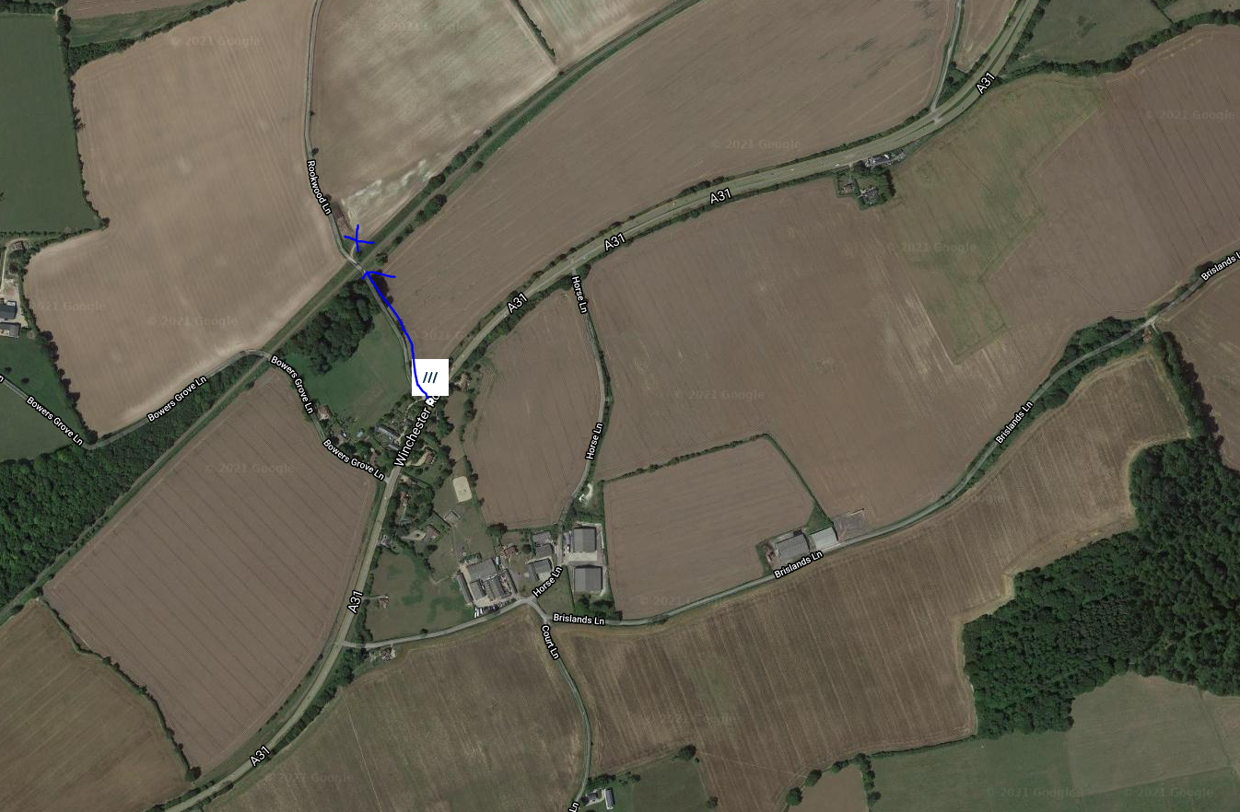

From the A31 Alton/Farnham
Follow signs for A31 Winchester and go through Four Marks. You will pass a small parade of shops and a BP garage on your right.
Continue along A31 Past the Travel Lodge on your right and join the dual carriageway
The entrance to the field will be on your right about ¼ mile after the dual carriageway returns to single lane.

Any problems call Debbie on 07776 195105 or Judy Hempstead on 07747 53308

