TRAINING DAY MANOR FARM ROPLEY
Morning Group will run 9:30am Arrival for a 10am start
Directions for the Morning training group;
Directions - Manor Farm, Rookwood Lane, Ropley, Hants, SO24 0DF
Please note the morning training will take place off the A31 and not at the actual Farm buildings. The What3Words for this location is https://w3w.co/plot.intention.expose
The training will be signposted with WMRC signs off the main road.

From the A34 or M3 at Winchester follow signs for A31 Alresford/Alton
At the Percy Hobbs Roundabout (Neptune at home) take the third exit A31 to Alresford
At the next roundabout take the 2nd exit onto A31
At the roundabout take the 2nd exit and stay on the A31
Pass the Shell Garage and Thai restaurant and continue for two miles. Go past the sign for
North Street and a road on your left to Bighton and the bus stop, the turning into the field
will then be about 5 yards on your left up a gravel track.
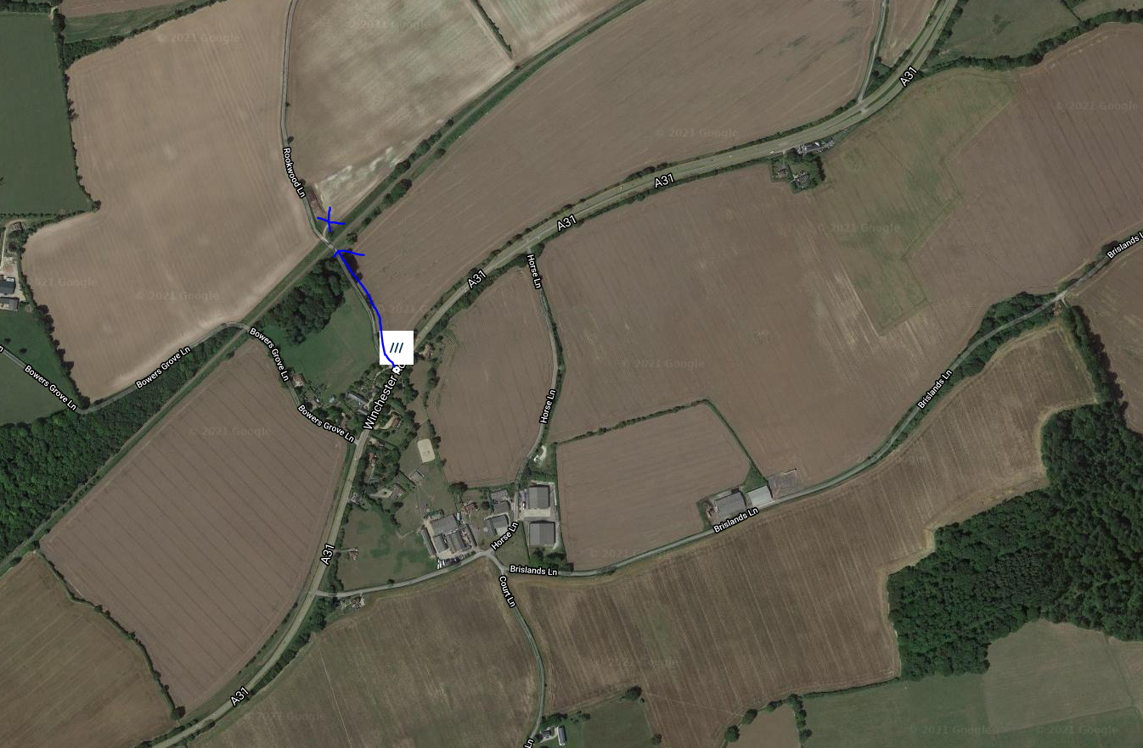

From the A31 Alton/Farnham
Follow signs for A31 Winchester and go through Four Marks. You will pass a small parade of
shops and a BP garage on your right.
Continue along A31 Past the Travel Lodge on your right and join the dual carriageway
The entrance to the field will be on your right about ¼ mile after the dual carriageway
returns to single lane.
Afternoon Group will run 12:30 Arrival for a 1pm start
Directions for the Afternoon training group;
Directions - Manor Farm, North Street, Ropley, Hants, SO24 0DF
Please note the afternoon training will park at the Farm buildings. The What3Words for this location is https://w3w.co/skillet.pulse.baguette
The training will be signposted with WMRC signs off the main road.

From the A34 or M3 at Winchester follow signs for A31 Alresford/Alton
At the Percy Hobbs Roundabout (Neptune at home) take the third exit A31 to Alresford
At the next roundabout take the 2nd exit onto A31
At the roundabout take the 2nd exit and stay on the A31
Pass the Shell Garage and Thai restaurant and continue for two miles. Turn right at the sign for North Street and follow the road taking the left fork towards the farm buildings,
Parking will be in front of the barns.
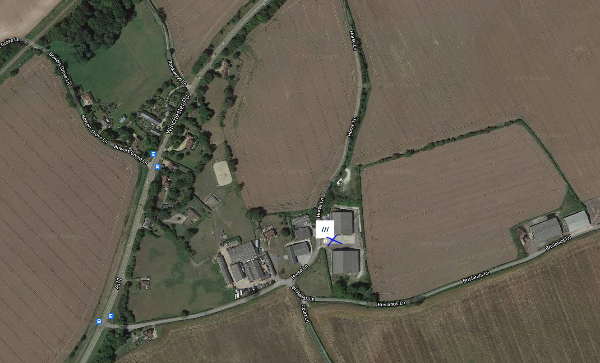
From the A31 Alton/Farnham
Follow signs for A31 Winchester and go through Four Marks. You will pass a small parade of shops and a BP garage on your left.
Continue along A31 Past the Travel Lodge on your right, and join the dual carriageway, once the dual carriageway returns to one lane, continue o half a mile, past a sign to Bighton (on your right) and then take the next left heading towards the farm buildings. (If you get to the Thai restaurant and the Shell garage you have missed the turning.
Any problems call Debbie on 07776 195105 or Judy Hempstead on 07747 53308

