**Location Details Oxford Training**

Field Barn Farm, Garford, Oxon.

The postcode OX13 5PB will put you in the right area. DO NOT go into Garford village, stay on the A338 and look for your club training signs WMRC

Once off the main road, follow the arrows through the farm units and along the concrete road.

any problems on the day contact John 07901673441.

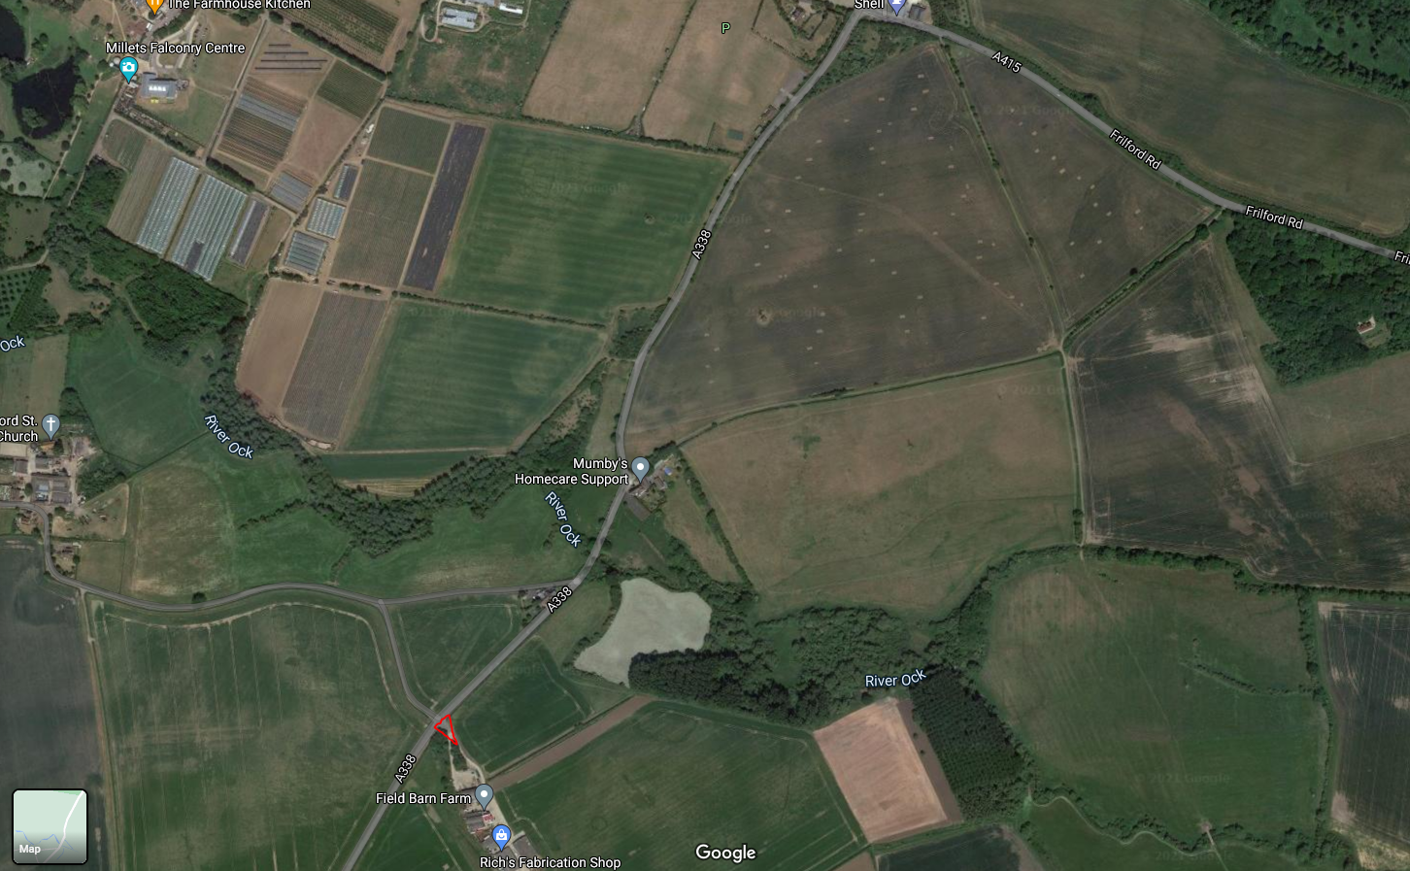

For those who use the what3words app the driveway is ///stunner.outwards.saying